Let’s Try!
Name: | Grade: | Class:
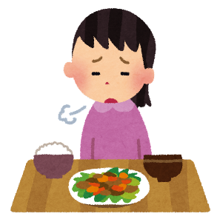
- Q: Have you finished your lunch yet?
A: No, _________________________________________
(no / finished / I / not / lunch / have / yet / my / .)
- Q: Have you already clean your room?
A: Yes, ________________________________________
(cleaned / room / have / my / I / already / .)
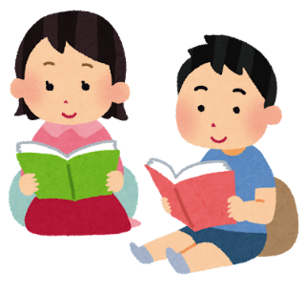
- Q: Has she already read this book yet?
A: Yes, ________________________________________
(already / read / she / book / has / this / .)
(2)二度
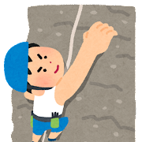
- Q: Have you ever climbed Mt. Fuji?
A: Yes, _________________________________________
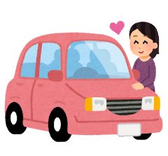
(twice / climbed / have / Mt. Fuji / I / .)
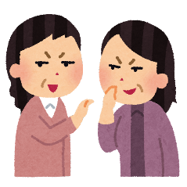
- Has she driven her new car yet?
A: No, ___________________________________________
(yet / new / driven / her / she / car / hasn’t / .)
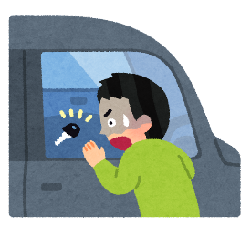
- A: ________________________________________________
(found / just / key / my / have / I / .)

- A: _________________________________________________
(his/ bought / he / new / house / just / has / .)
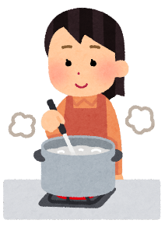
- Q: _________________________________________________
(yet / you / have / cooked / dinner / ?)
- A: _________________________________________________
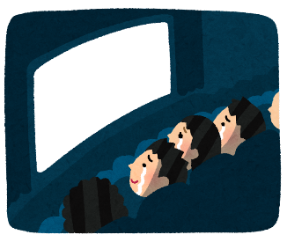
(already / have / I / cooked / dinner / .)
- A: ______________________________________________
(movie/ we / just / have / watched / the / .)

