Name: Class: Number:

Janken Gestures!

Play Janken!
Winner: “Walk”とか
Loser: gestureをする
Start

run
Write your name
walk

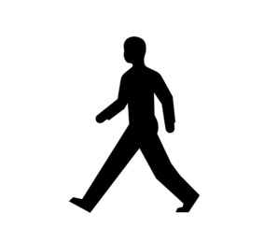

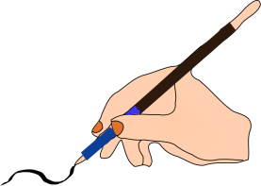

Close your book
Open your book
Raise your
hand

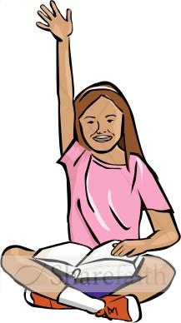

Look at the board
Listen to the CD
Repeat after me

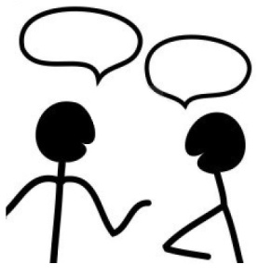
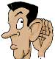

ALT’s signature:
Finished!

Word Search
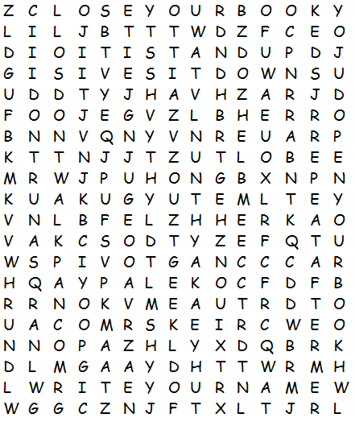

Any volunteers? Raise your hand.
Close your book. Repeat after me.
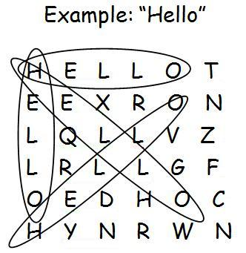
Don’t run. Run!
Don’t walk. Sit down.
Listen to the CD. Stand up.
Look at the Board. Walk.
Open your book. Write your name.

