Yes, she/he has.
No, she, he has not. {hasn’t}
Have they finish it yet?
Have Baymax and Mikasa finished their lists?

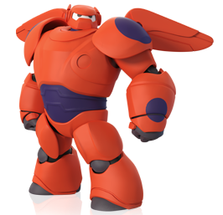
To do list:
- Feed the dog.
- Clean the house.
- Wash the car.
- Make a bento box.
- Save the world.
8:00 am feed the dog.
10:00am clean the house.
12:00pm have lunch.
2:00pm wash the car.
4:00 pm save the world.
Now 4:30pm

- Has Baymax cleaned the house yet? ______________________________
- Has he washed the car yet? ___________________________________
- Has he done his homework yet? ____________________________________
- Has he made a bento box yet? ___________________________________
- What has he just done? _________________________________________
To do list:
- Eat breakfast.
- Fight Giant.
- Go to Mos Burger.
- Wash the dishes.
- Play video games.
7:30 am eat breakfast.
9:00 am wash the laundry. 洗濯物
10:00 am fight a Giant. 巨人
12:00 pm go to Mos Burger.
2:00 pm do homework.
4:00 pm play video games.
Now 4:30pm
- Has Mikasa washed the laundry? __________________________________________
- What task任務has Mikasa not done? _______________________________________
- Has she done all her tasks? ________________________________________________
- What has she just done?___________________________________________________
- What hasn’t she done yet? ________________________________________________

