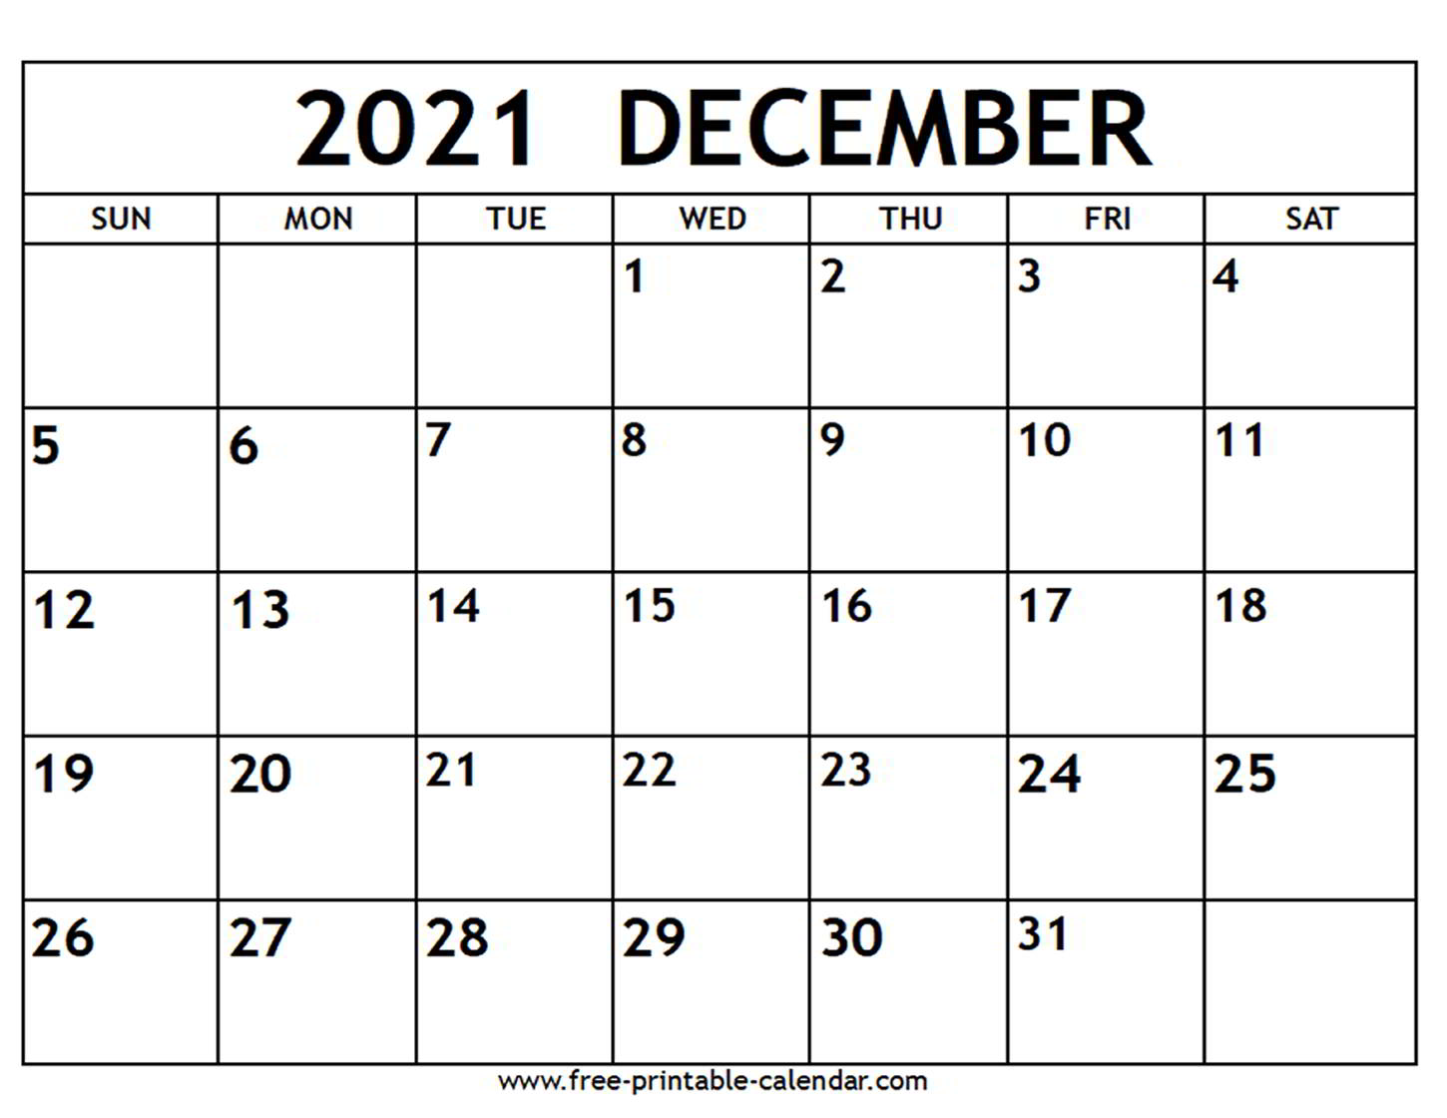

Rohatsu

Last night of Hanukkah

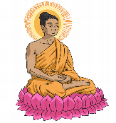

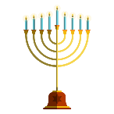

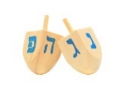

First Airplane

Kenya`s Independence Day



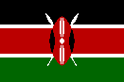

Winter Solstice

Christmas

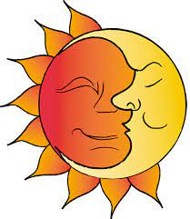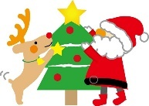

Boxing Day



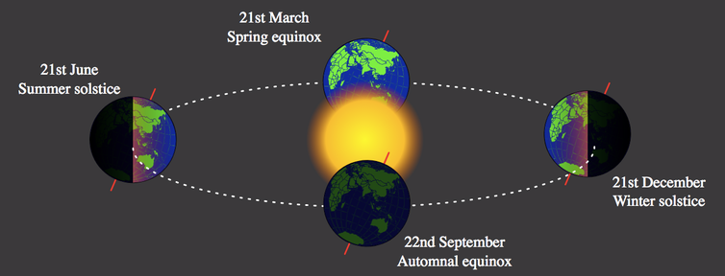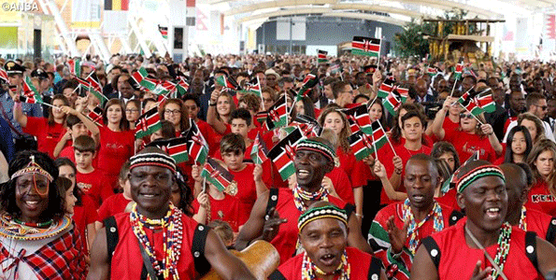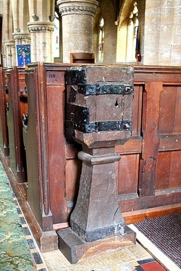

Words:

is celebrated 祝われた

day after 翌日

the poor 貧民

colony 植民地

independence 自立

parades 行進

shortest 一番短い

longest 一番長い

candles ろうそく

garlands 葉っぱ輪

The winter solstice is the **shortest** day and **longest** night in the year. Some people celebrate by lighting **candles** and making **garlands**.

Kenya`s Independence Day

Kenya was a **colony** of the UK for 126 years.

In 1963 they finally got their **independence**!

They celebrate this day with **parades**, parties, and dancing.

What is Boxing Day?

It is **celebrated** in the UK.

It is the **day after** Christmas.

People put money and gifts in

boxes to give to **the poor**.