Tina’s grandpa is Santa.
Tina’s grandma is a witch.
Tina’s mother is a ghost.
Tina’s father is a vampire.
Tina’s aunt is a magician.
Tina’s uncle is a werewolf.
Tina’s cousin is a zombie.
Nick is Zoro.
Tina is a mummy.

Mummy’s father’s father is Santa.
Vampire’s sister’s moｍ is a witch.
Zombie’s cousin’s mother is a ghost.
Mummy’s aunt’s brother is a vampire.
Zombie’s cousin’s father’s sister is a magician.
Zoro’s cousin’s father is a werewolf.
Mummy’s cousin is a zombie.
Zombie’s cousin’s brother is Zoro.
Zombie’s cousin’s sister is a mummy.

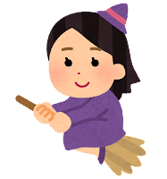
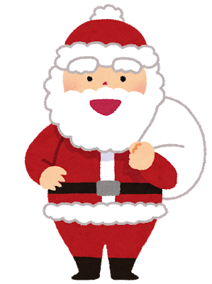
______________________
______________________
______________________
Tina’s family
______________________
______________________
______________________
______________________
______________________
______________________
