Werewolf | Werewolf | Werewolf | Doctor
Seer | 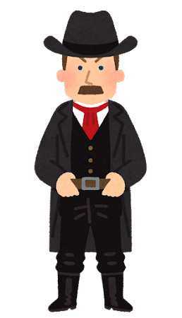  Sheriff | 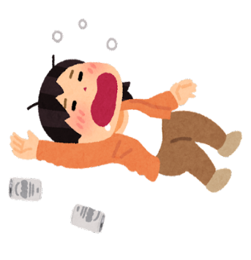  Drunk | Witch
Villager | Villager | Villager | Villager
Villager | Villager | Villager | Villager
Villager | Villager | Villager | Villager
Villager | Villager | Villager | Villager
Villager | Villager | Villager | Villager
Villager | Villager | Villager | Villager

