|  |  |
| --- | --- |
| Battle Point A |  |
| Battle Point B |  |
| Battle Point C |  |
| Battle Point D |  |
| Battle Point E |  |
| Battle Point F |  |
| Battle Point G |  |
| Battle Point H |  |

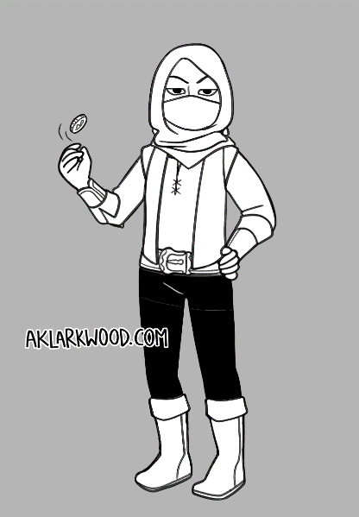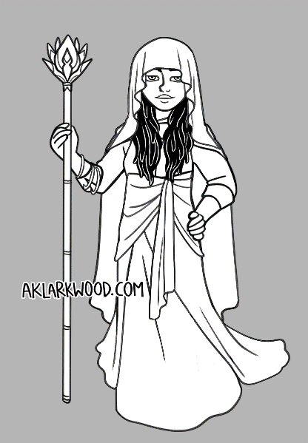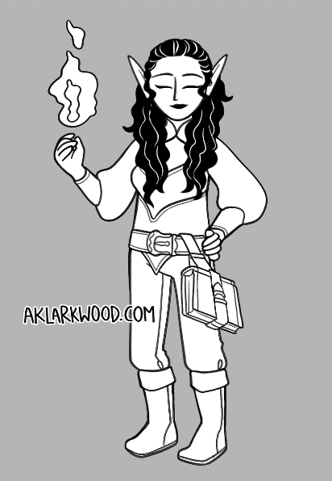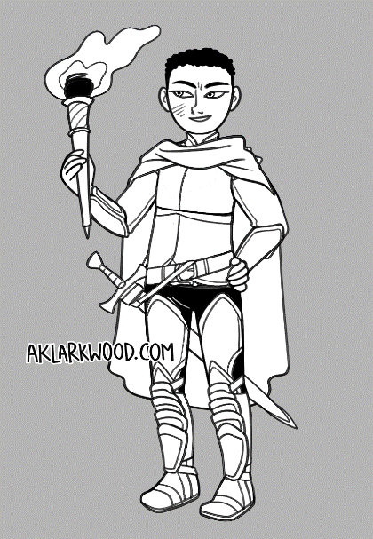

Battle Log

**120**

**80**

**60**

**50**

**100**

**50**

**120**

**50**

**100**

**50**

**120**

**100**

**HP:**

**HP:**

**HP:**

**MP:**

**MP:**

**MP:**

**STA:**

**STA:**

**STA:**

**STA:**

**MP:**

**HP:**

Assassin

Swordsman

Healer

Mage

Choose your character!

Name：＿＿＿＿＿＿＿＿＿

Grade：＿＿

Class：＿＿