Name: ________________ Class: _____ Number: _____ Date: ___/___

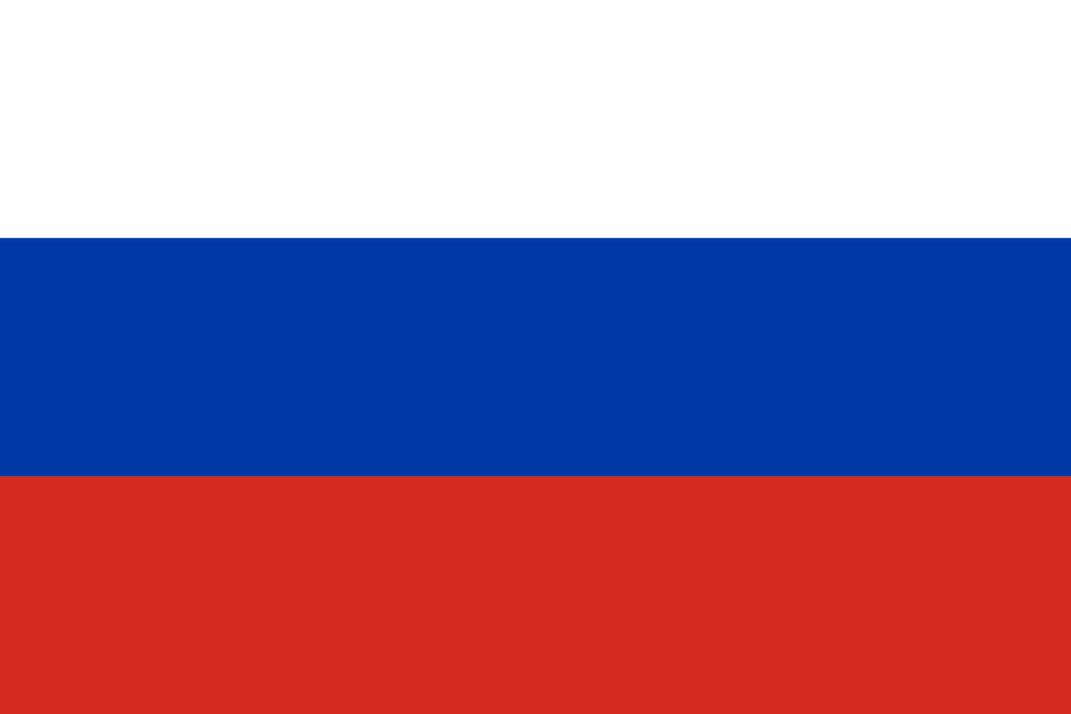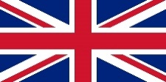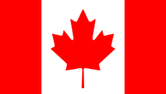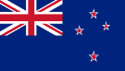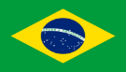

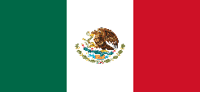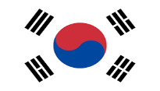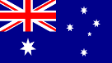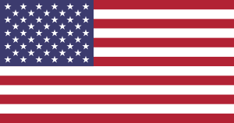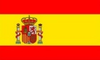

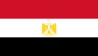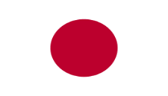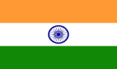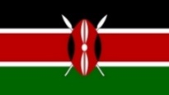

1. I want to go to _________ to __________________________
2. I want to go to _________ to __________________________
3. I want to go to _________ to __________________________
4. I want to go to _________ to __________________________
5. I want to go to _________ to __________________________
6. I want to go to _________ to __________________________
7. I want to go to _________ to __________________________
8. I want to go to _________ to __________________________
9. I want to go to _________ to __________________________
10. I want to go to _________ to __________________________
11. I want to go to _________ to __________________________
12. I want to go to _________ to __________________________

WHERE DO YOU WANT TO GO THIS SUMMER? WHY?

___________________________________________________________________________________________________

___________________________________________________________________________________________________

___________________________________________________________________________________________________

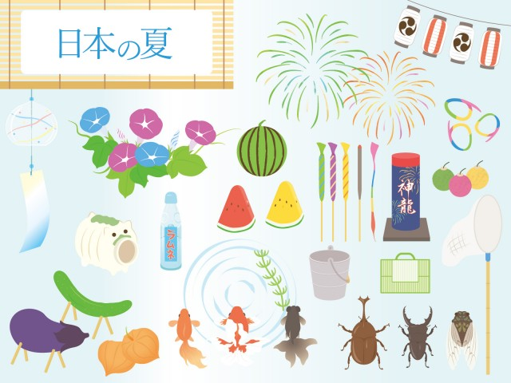

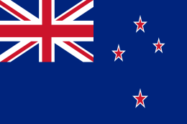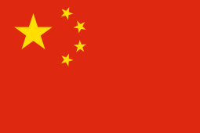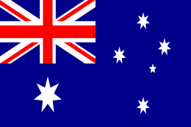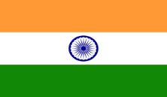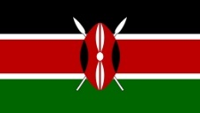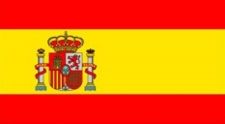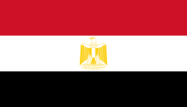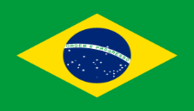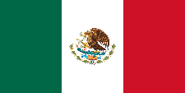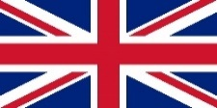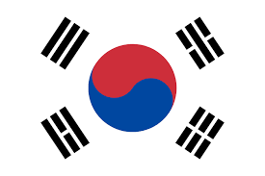

Brazil

India

Kenya

Australia

New Zealand

Japan

Canada

Italy

America

Egypt

Spain

Mexico

The UK

Korea

Russia

China

Mexico

The UK

New Zealand

Canada

Russia

China

Japan

Korea

Brazil

Spain

Egypt

Kenya

India

America

Australia

Italy