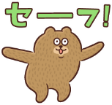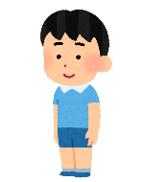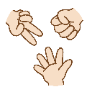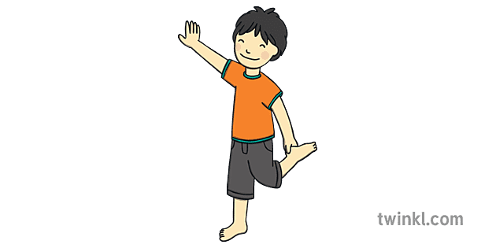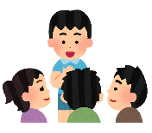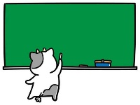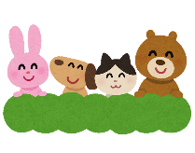

**S**

**A**

**F**

**E**

**S A F E**

**S A F E**

**JUST DO IT**

**Please spell your name.**

**K-O-T-A**

**Stand up. Don’t sit for 1 round.**

**Stand on 1 foot. Don’t move for**

**10 seconds.**

**Please ask your members:**

**What food don’t you like?**

**Let’s call Gordon-sensei and ask a question.**

**Count 10~1 backwards.**

**10, 9, 8, 7, 6, 5, 4, 3, 2, 1**

**Write your name in Romaji on the blackboard.**

**Don’t play for 1 round.**

**Let’s say our favorite character.**

**Read this 3 times: A big black bug bit a big black bear.**

**Name 5 sports**

**in English.**

**GO BACK TO START.**

**Name**

**5 subjects**

**in English.**

**Name 5 countries**

**in English.**

**Don’t move for 10 seconds.**

**Please say your full name.**

**Please draw Anpanman on the board.**

**Blink your eyes ten times.**

**Let’s play janken. Winner says his/her favorite food.**

**Please sing the alphabet from A to Z.**

**Don’t close your eyes for 10 seconds.**

**Jump 5 times.**

**Name 5 colors in English.**

**Name**

**5 animals**

**in English.**

**Let’s sing a Japanese song.**

**Let’s say our favorite color.**

**Let’s call Jessie and ask a question.**

**Let’s dance Butter by BTS.**

**S**

**A**

**F**

**E**

**Name 5 fruits in English.**