Japan & UK School Rules
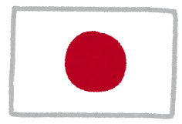

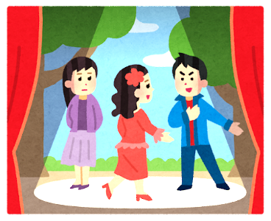
bell = チャイム ring = 鳴る
cafeteria = 食堂 grades = 成績
all-school meeting = 全学集会
A. | You have to study English.
B. | You have to study Japanese.
C. | Students have to change classroom and teachers don’t have to move.
D. | You do not have to take tests.
E. | You do not have to buy notebooks.
F. | You have to clean the school.
G. | You do not have to go to school.
H. | You do not have to study drama
I. | You have to wear a school uniform.
J. | You have to sit down before the bell rings.
K. | You have to eat lunch in the cafeteria.
L. | You have to study French or German.
M. | You have to go to  all-school meetings.
N. | You have to change your shoes.

Answers:
Japan: B, F, H, N,
UK: C, E, K, L
Both: A, I, J, M
Neither: D, G,

