set the table | clear the table | take out the trash | walk the dog
get the newspaper | clean my room | clean the bath | cook breakfast/lunch/dinner
wash the dishes | sweep the floor | vacuum the floor | water the plants
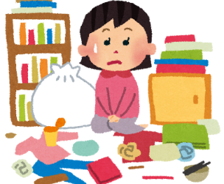
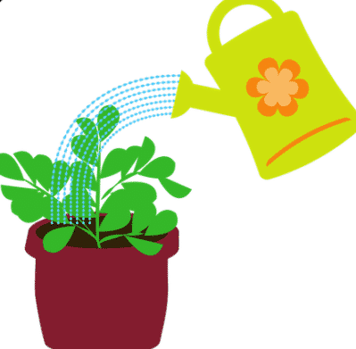
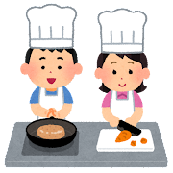

1.__________________ 2._________________ 3.__________________
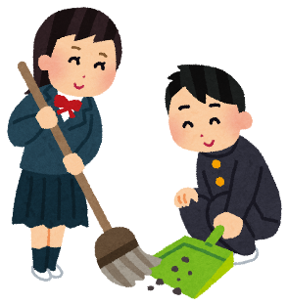
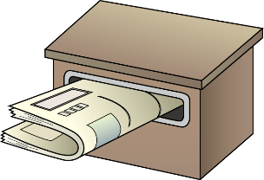

4.__________________ 5._________________ 6.__________________
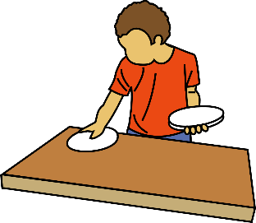
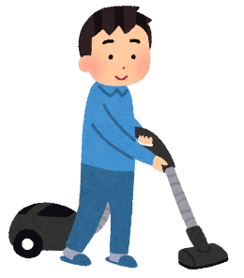
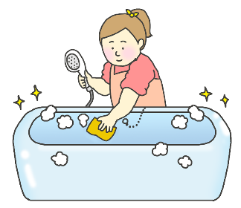

7.__________________ 8._________________ 9.__________________
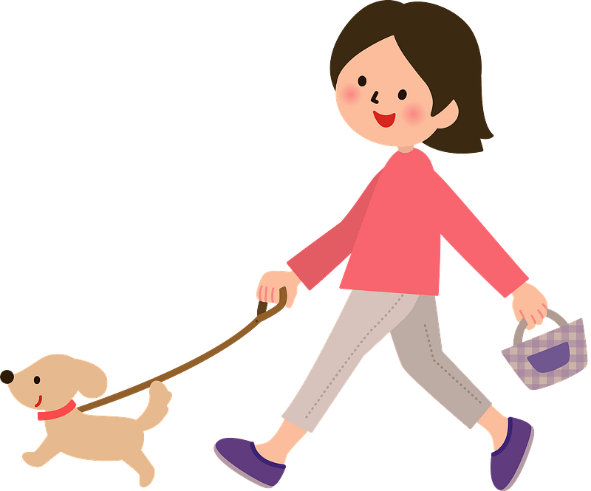
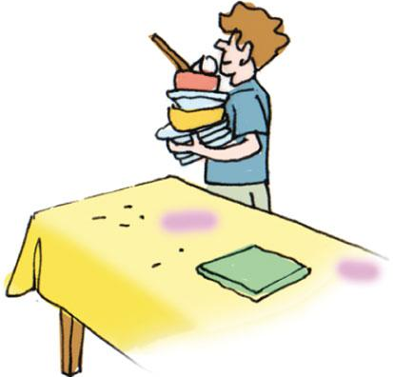

For example:
I have to (wash the dishes).
I like doing it because (it’s relaxing).
I sometimes (clean my room).
I don’t like doing it because (it’s not fun).
I don’t have to (water the plants).
My (sister) does it.
Your turn:
I have to
I (don’t) like doing it because

I sometimes
I (don’t) like doing it because

I don’t have to
My does it.

