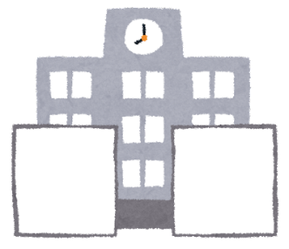  Near the gate | 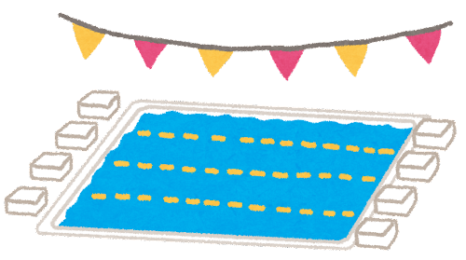  In front of the pool | 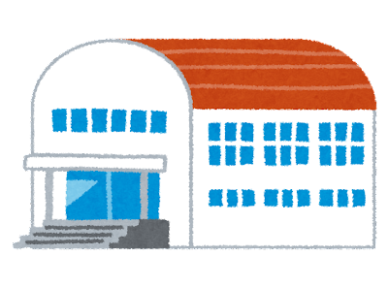  In front of the gym | Between the field and gate | Near the gate
Near the gate | In front of the pool | In front of the gym | Between the field and gate | Between the gym and pool
Near the gate | In front of the pool | In front of the gym | Between the field and gate | In front of the pool
Between the gym and pool | Behind the pool | Behind the gym | Behind the gym | Behind the pool
Between the gym and pool | Behind the pool | Behind the gym | In front of the gym | Between the field and gate
Between the gym and pool | Behind the pool | Behind the gym | 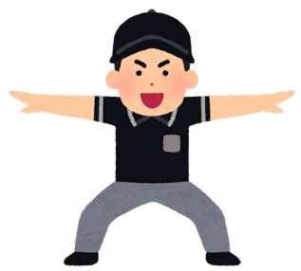  Safe! | Safe!
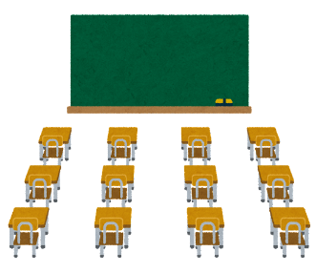  Near the classrooms | Near the classrooms | On the sports field | On the sports field | Safe!
Near the classrooms | Near the classrooms | On the sports field | On the sports field | Safe!

