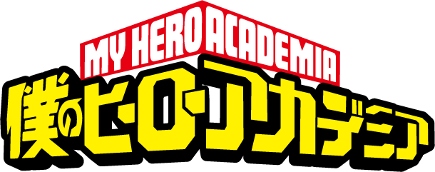
Name:___________________________Class:________Program Number:_____
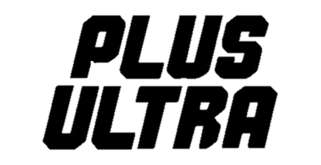

Write down the correct word in English. Correct word
and spelling = 1 point.
PHASE 1
Round 1

- ______________________ 2. ______________________ 3. ______________________

- ______________________ 5. ______________________ 6. ______________________
Round 2

- ______________________ 2. ______________________ 3. ______________________

- ______________________ 5. ______________________ 6. ______________________
Round 3

- ______________________ 2. ______________________ 3. ______________________

- ______________________ 5. ______________________ 6. ______________________
SCORE RESULTS: What is your total score?
___/18
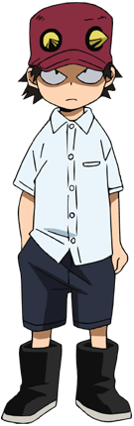
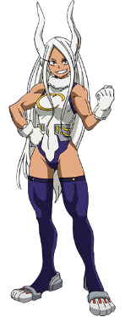
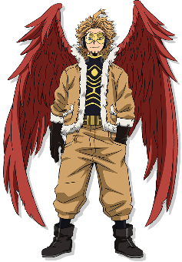
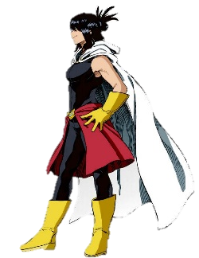
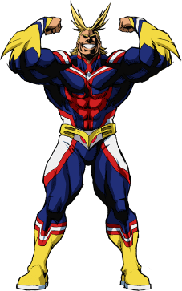

個性needs work
Hero in training
Pro Hero
Super Hero
0~3 points
4~8 points
9~13 points
14~18 points
Notes:

