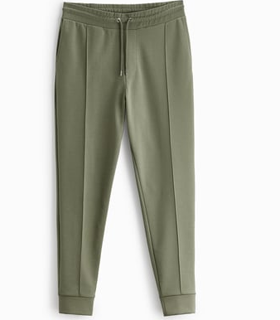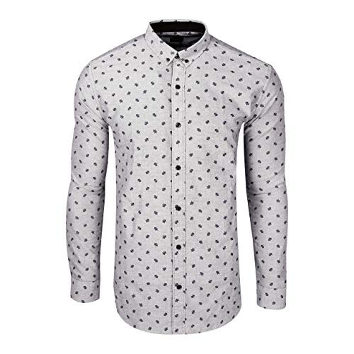
Leather Jacket Pants Men`s shirt
Black Green Black and White
$5000 $4000 $3000

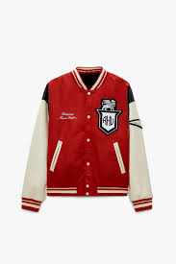
Plaid Shirt Ripped Jeans Jacket
Black and White Blue Red and White
$5000 $4000 $3000

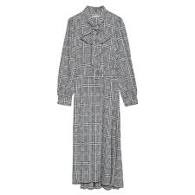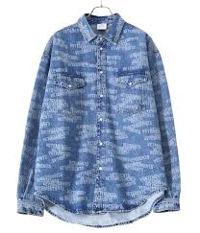
Pleated Skirt Long dress Shirt
Black Black and White Blue and White
$2000 $3000 $4000

