Cooking Vocabulary
These are the ___________  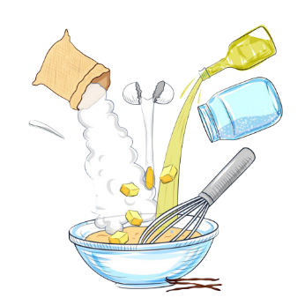 | ___________ the apple  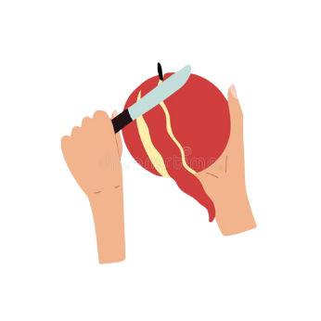 | ___________ the carrots  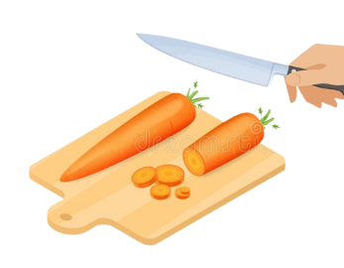
___________ the potatoes  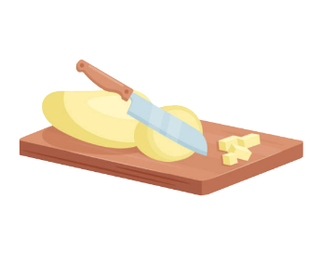 | ___________ the garlic  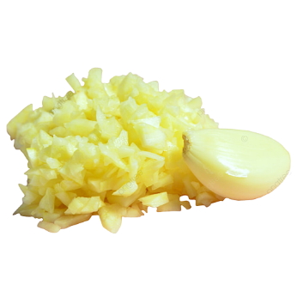 | ___________ the eggs  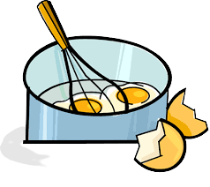
___________ the flour  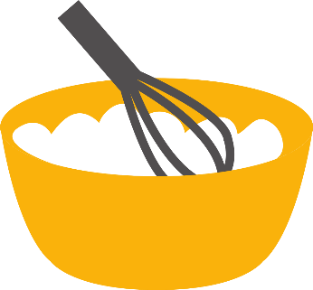 | Add the ___________  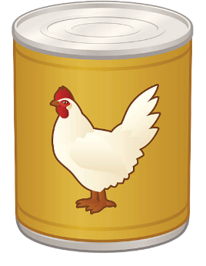 | ___________ the onions  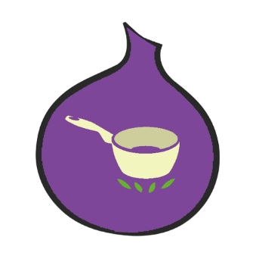
___________ the vegetables  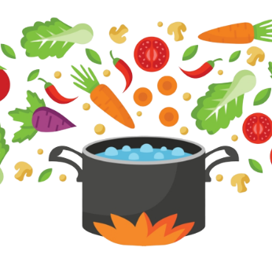 | Let it ___________  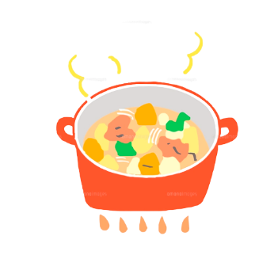 | Use ~ as ___________  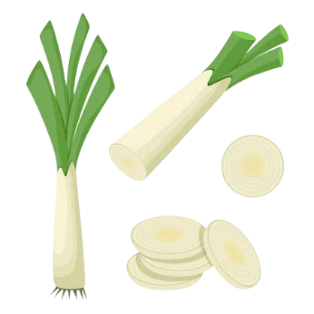

dice | beat | peel | mix
stock / broth | ingredients | cut / chop | boil
garnish | mince | simmer / stew | saute
Miss Janeth’s Book of Recipes
Today, I will teach you how to make ______________________
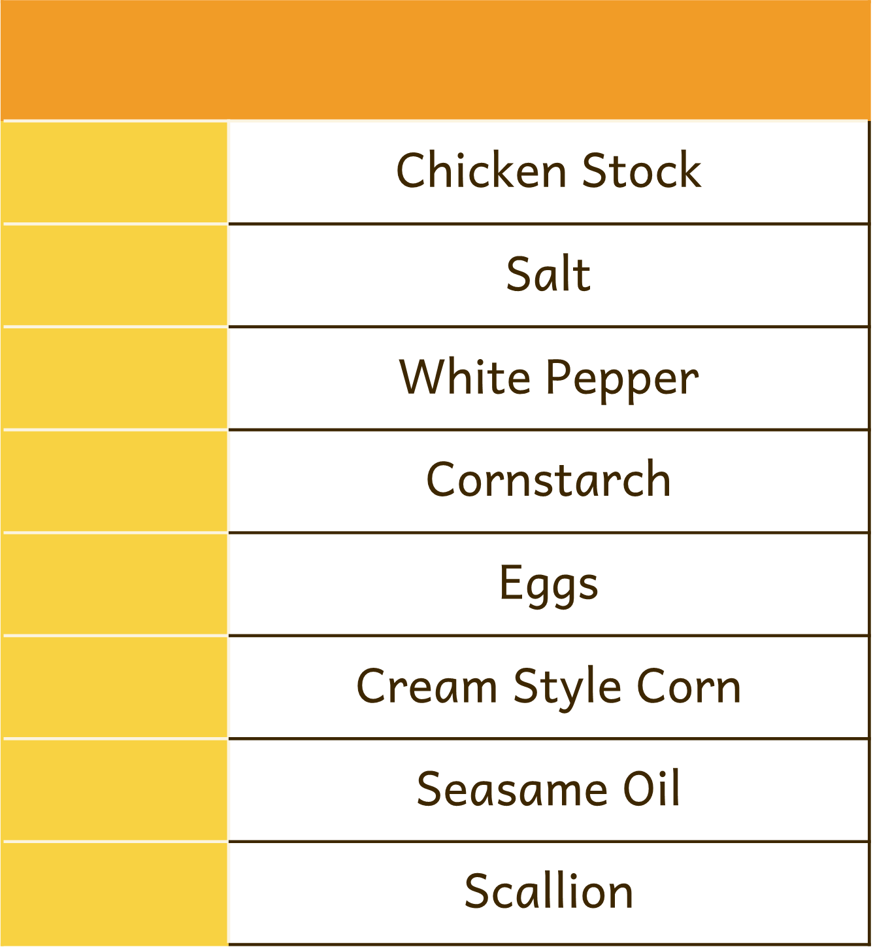
These are the ________________________
You will need

3 | 4 tbsp | 4 cups | 1/8 tsp | 1 can | 1 | ¾ tsp | 1/2 tsp

Step _____ | Taste the soup, and adjust the seasoning if needed.
Step _____ | Use the chopped scallions as garnish and enjoy!
Step _____ | On a medium size pot, add the chicken broth and let it simmer.
Step _____ | In a separate container, Mix well the cornstarch with some cold water.  Slowly add the mixture and stir it well.
Step _____ | Stir in the sesame oil, salt, white pepper and can of cream style corn.
Step _____ | Lightly beat the eggs in a bowl. Slowly* add the eggs and stir the soup to your liking

