Weird Festivals name: ______________ class: ___ number: ___

- Is there a ___________________________________ ?
Yes, there is. / No, there isn’t.
- Is there a ___________________________________ ?
Yes, there is. / No, there isn’t.
- Is there a ___________________________________ ?
Yes, there is. / No, there isn’t.
- Is there a ___________________________________ ?
Yes, there is. / No, there isn’t.
- Is there a ___________________________________ ?
Yes, there is. / No, there isn’t.
- Is there a ___________________________________ ?
Yes, there is. / No, there isn’t.
- Is there a ___________________________________ ?
Yes, there is. / No, there isn’t.
- Is there a ___________________________________ ?
Yes, there is. / No, there isn’t.
- Is there a ___________________________________ ?
Yes, there is. / No, there isn’t.
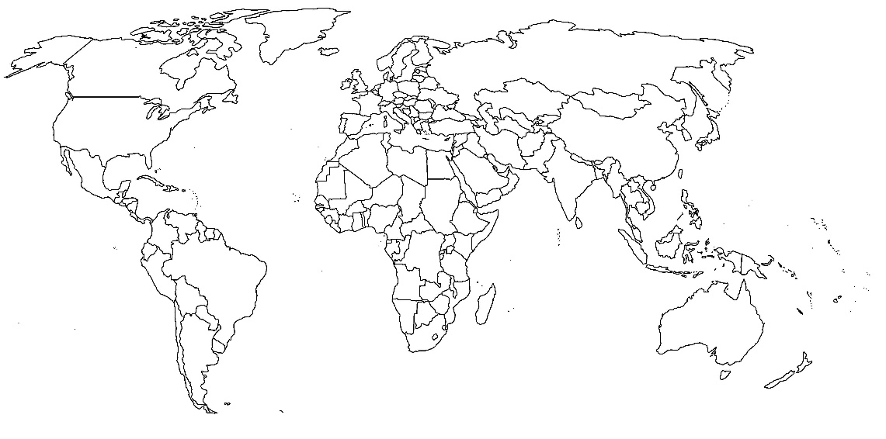
- Are there __________________________________ ?
Yes, there are. / No, there aren’t.

