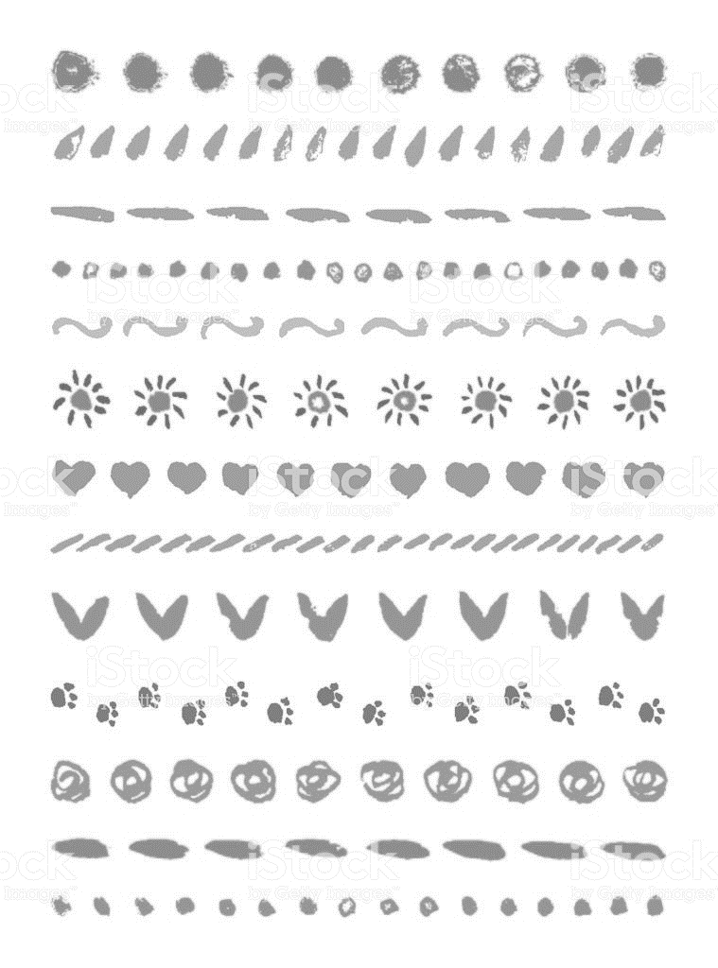ひらがなで名前：　　　　　　　　　　　　　。

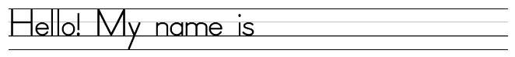

|  |  |  |
| --- | --- | --- |
| Handwriting Lines Clipart Black And White | Handwriting Lines Clipart Black And White | Handwriting Lines Clipart Black And White |
| Handwriting Lines Clipart Black And White | Handwriting Lines Clipart Black And White | Handwriting Lines Clipart Black And White |
| Handwriting Lines Clipart Black And White | Handwriting Lines Clipart Black And White | Handwriting Lines Clipart Black And White |

File:Scissors icon black.svg - Wikimedia Commons

File:Scissors icon black.svg - Wikimedia Commons

|  |  |  |
| --- | --- | --- |
| Handwriting Lines Clipart Black And White | Handwriting Lines Clipart Black And White | Handwriting Lines Clipart Black And White |
| Handwriting Lines Clipart Black And White | Handwriting Lines Clipart Black And White | Handwriting Lines Clipart Black And White |
| Handwriting Lines Clipart Black And White | Handwriting Lines Clipart Black And White | Handwriting Lines Clipart Black And White |

My friends