**May I ? Janken Game**

Date: .Name: .

.

**START**

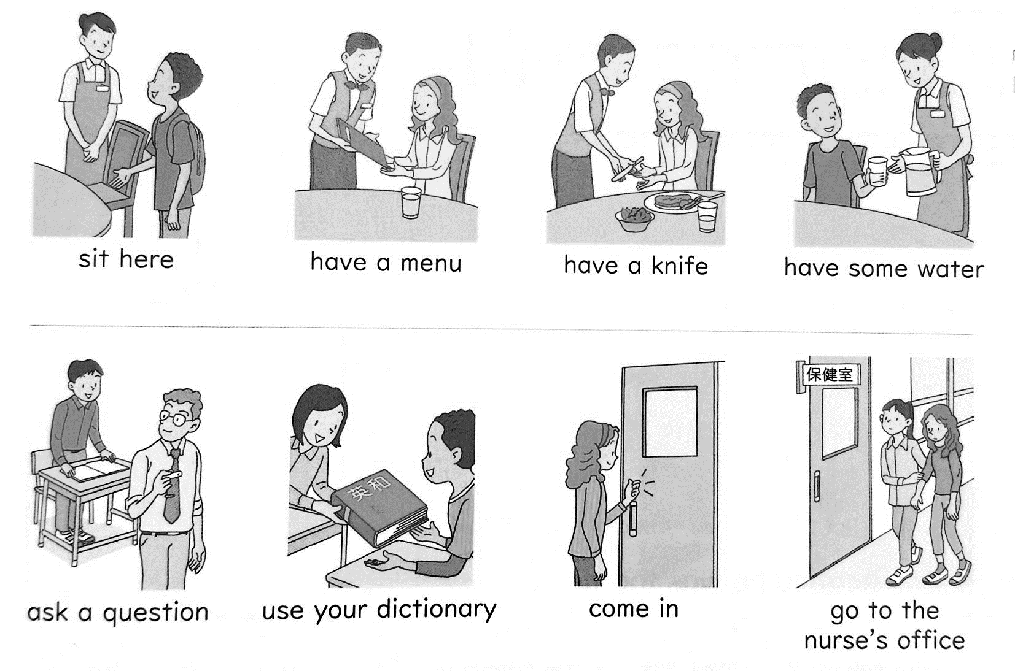

***JANKEN!***　W-san = 勝者 L-san = 敗者

*L-san:* Hello?

**W-san:** May I ?

*L-san:* Yes. / Sure. / No. / No way!

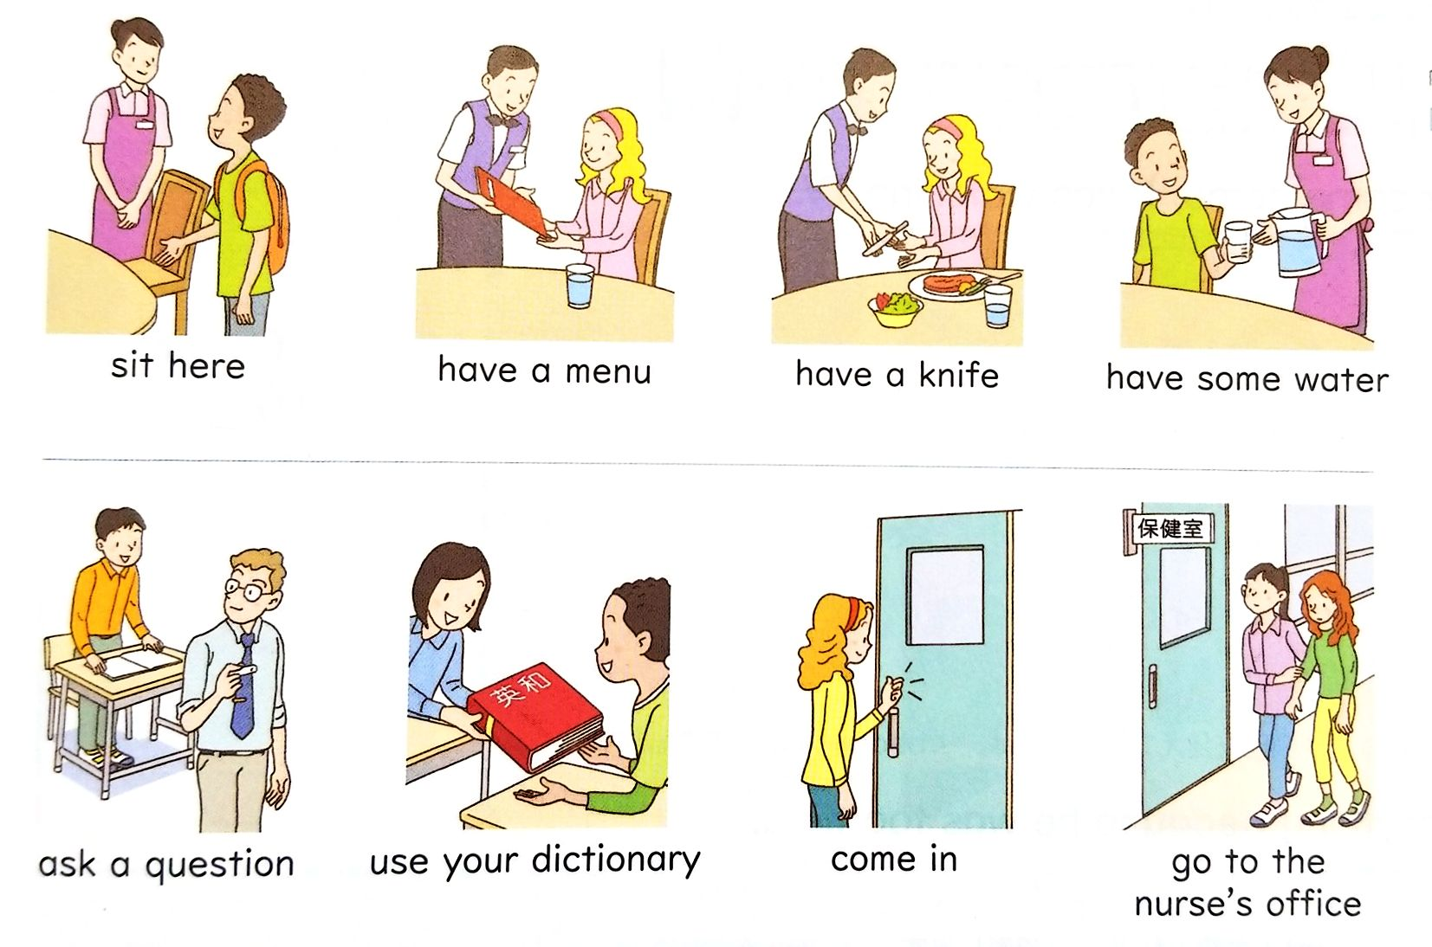

**FINISH**