Whose is it? Detective Game
1 | 2 | 3
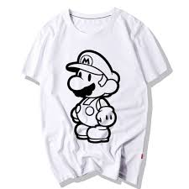 | 5 | 6

- Emi plays baseball and plays video games. She does not have a pet.

- Kota reads books and he plays the piano. He does not like cats.

- Jane has a pet and she likes the color black. She does not play sports.

- Saki likes to swim and she has a small pet. She does not like music.

- Erika likes music and comic books. She does not play video games.

- Alex likes to cook and he plays soccer. He does not like to read.

1. Whose cat is it?
2. Whose book is it?
3 Whose soccer ball is it?
4. Whose t-shirt is it?
5. Whose guitar is it?
6. Whose fish is it?

