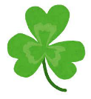Test Your Luck!

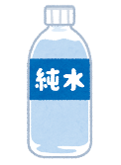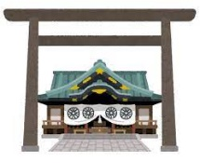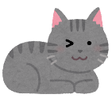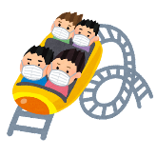

Yes, I

have.

**Today is not lucky! Be careful!**

No, I

haven’t..

**Have** you **drunk** water yet today?

No, I haven’t.

**Have** you **visited** a shrine yet this year?

**Today is your lucky day! Good things will happen!**

**Today is a little lucky. Maybe good things will happen!**

haven’t..

haven’t..

No, I

Yes, I

have.

No, I

Yes, I

have.

No, I

No, I

haven’t..

haven’t..

have.

Yes, I

have.

Yes, I

**Have** you **eaten** fruit yet today?

**Have** you ever **seen** a penguin?

More than 10 years.

Less than 10 years.

No, I haven’t.

Yes, I have.

Yes, I have.

**Have** you ever **had** a pet cat?

**Have** you **finished** studying for your English test yet?

**How long have** you **lived** in Nagasaki?

**Have** you ever **been** to an amusement park?