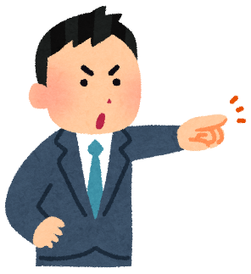
My family makes me…

例
My family makes me finish my homework after dinner. | 私の家族は夕食を食べた後私にに宿題をさせる。
My mother makes me clean the kitchen every week. | 私のお母さんは私に台所を毎週掃除をさせる。
My father makes me eat natto every night. | 私のお父さんは私に毎晩納豆を食べさせる。

How about you?
Me too…
My ________________ makes me __________________________________
______________________________________________________________
My ________________ makes me __________________________________
______________________________________________________________
My ___________________________________________________________
______________________________________________________________

In the future…

Good idea!
I will make my children ___________________________________________
______________________________________________________________
I will make _____________________________________________________
______________________________________________________________
I will __________________________________________________________
______________________________________________________________
I will __________________________________________________________
______________________________________________________________
