Name ___________________ Class ___ - ___

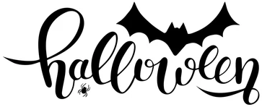

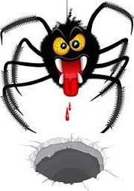
Creepy crawly critters crawl through creepy crawly craters

Professional pumpkin pickers are prone to pick the plumpest pumpkins

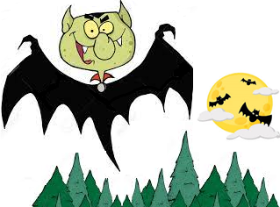
Transylvanian tree trimmers are trained to trim the tallest trees

