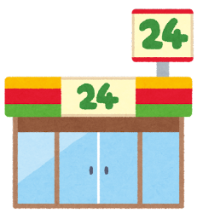
My Convenience Store
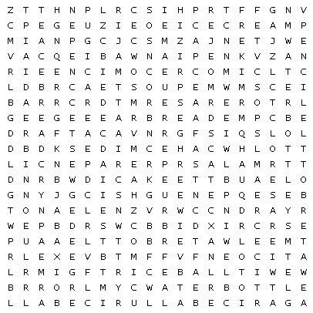

/5 bread
/5 comic
/5 eraser
/5 ice cream
/5 pencil
/5 rice ball
/5 tea
/5 water bottle

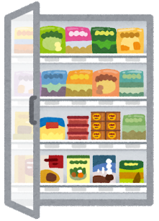
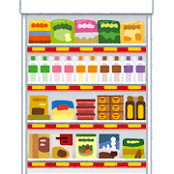
Part 1

ex// How many (breads) do you have?
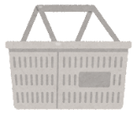
I have __________ bread(s)
Part 2
Let’s Write
- __I have__________________bread___________ I want to buy _________
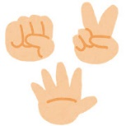
- __I have ________________________comic____ ex// + 5 breads
- _____have________________________eraser_____
- _____________________________ice cream______
- ______________________________pencil_________
- _______________________________rice ball______
- _____________________________________________
- _____________________________________________

