Hi, how are you?

I’m fine, thanks, and you?

I’m good, thanks.

Do you have a pen?

Yes, I do.

Cool! How many pens do you have?

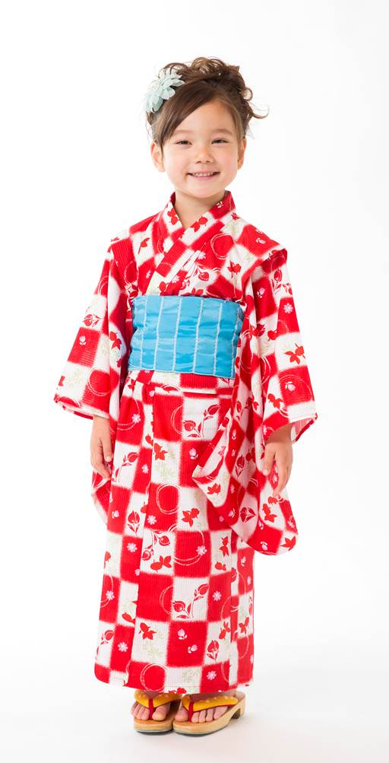
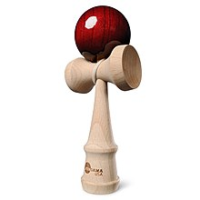
I have five pens.

Nice. Do you have an eraser?

No I don’t.

Oh, Ok. Do you have a glue stick?

Yes, I do.

