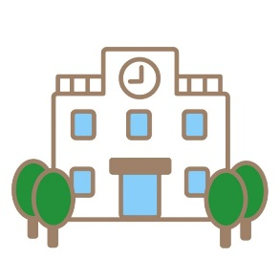
My Dream School Week
（全部の教科入れないといけない！）
Japanese | English | Math
Science | Social Studies | Music
PE | Fine Arts | Industrial Arts and Homemaking

 | Monday | Tuesday | Wednesday | Thursday | Friday
1st period
2nd period
3rd period
4th period
5th period
6th period

