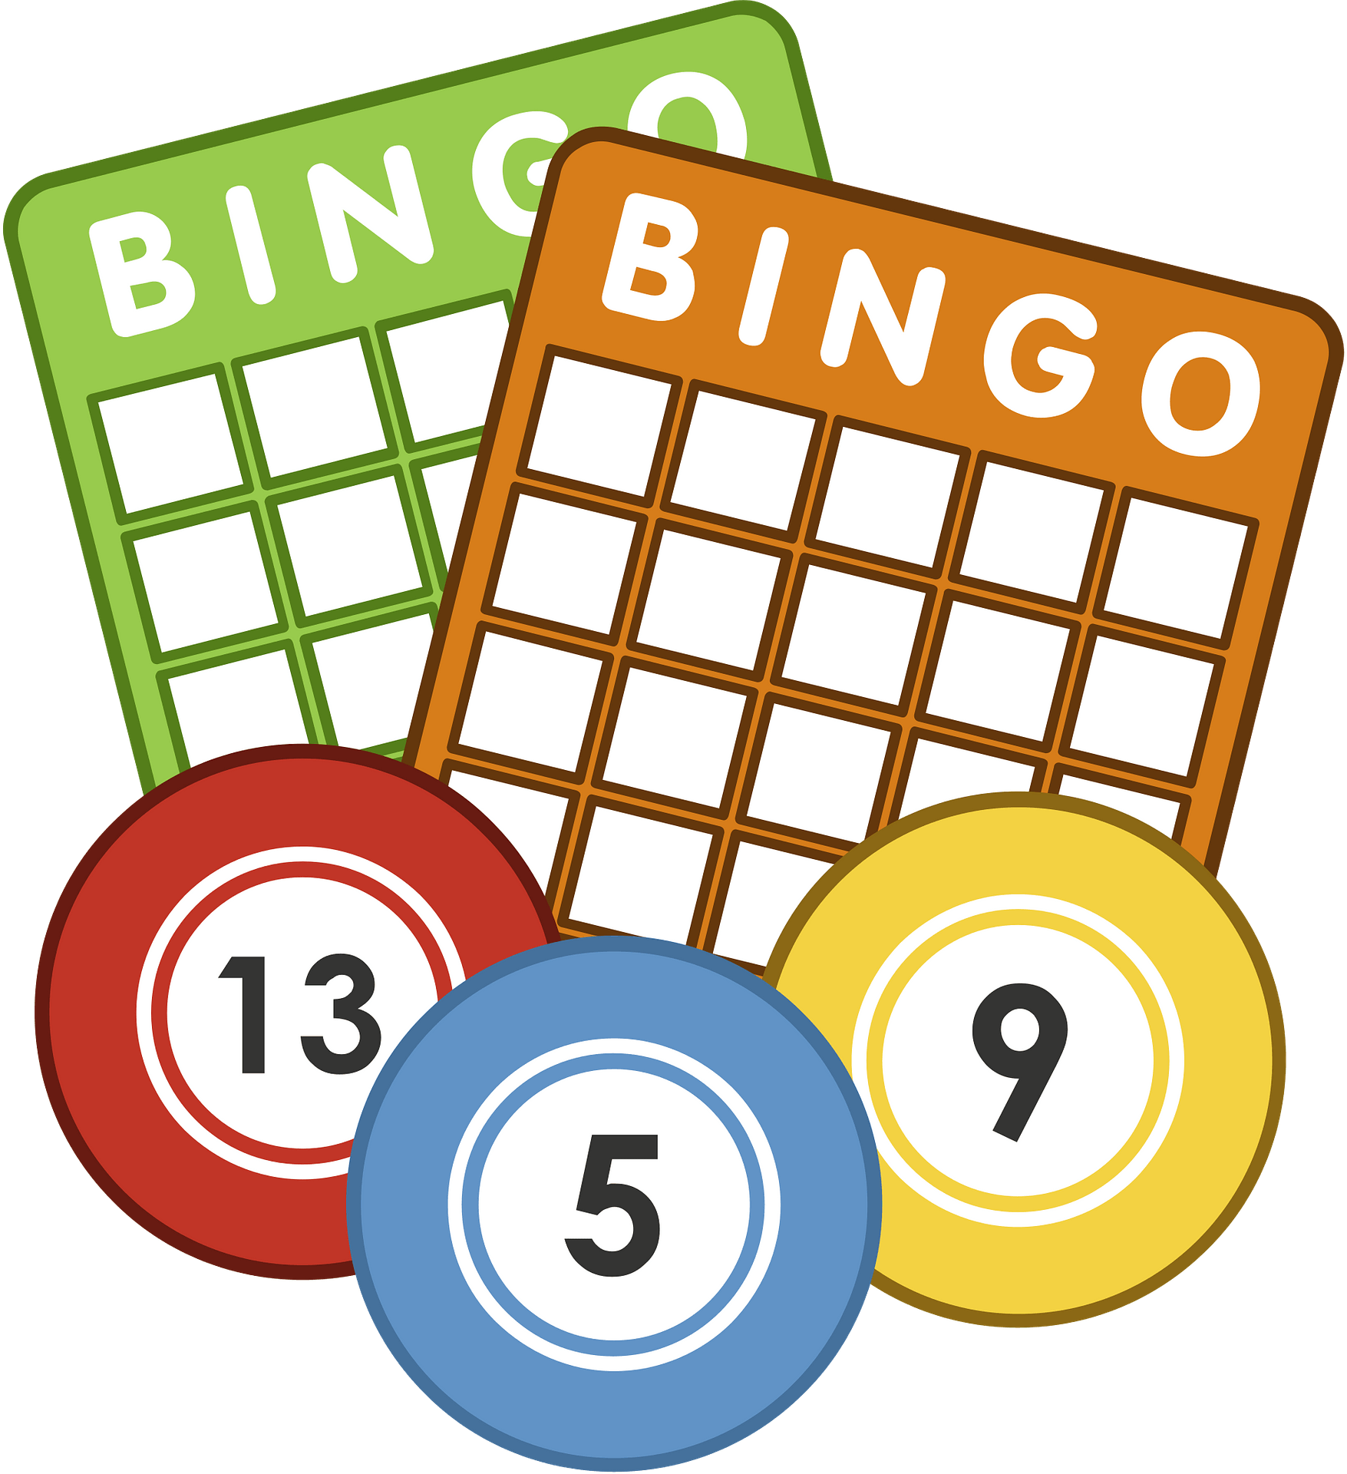
Name:____________________ Class: 2-____ No: ____

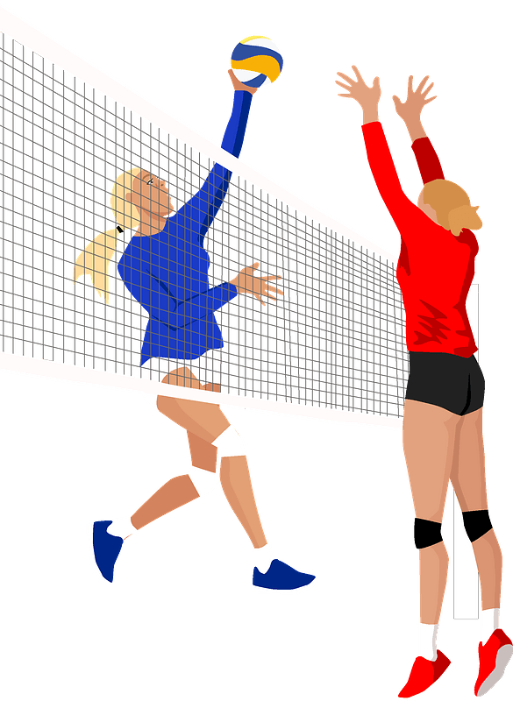
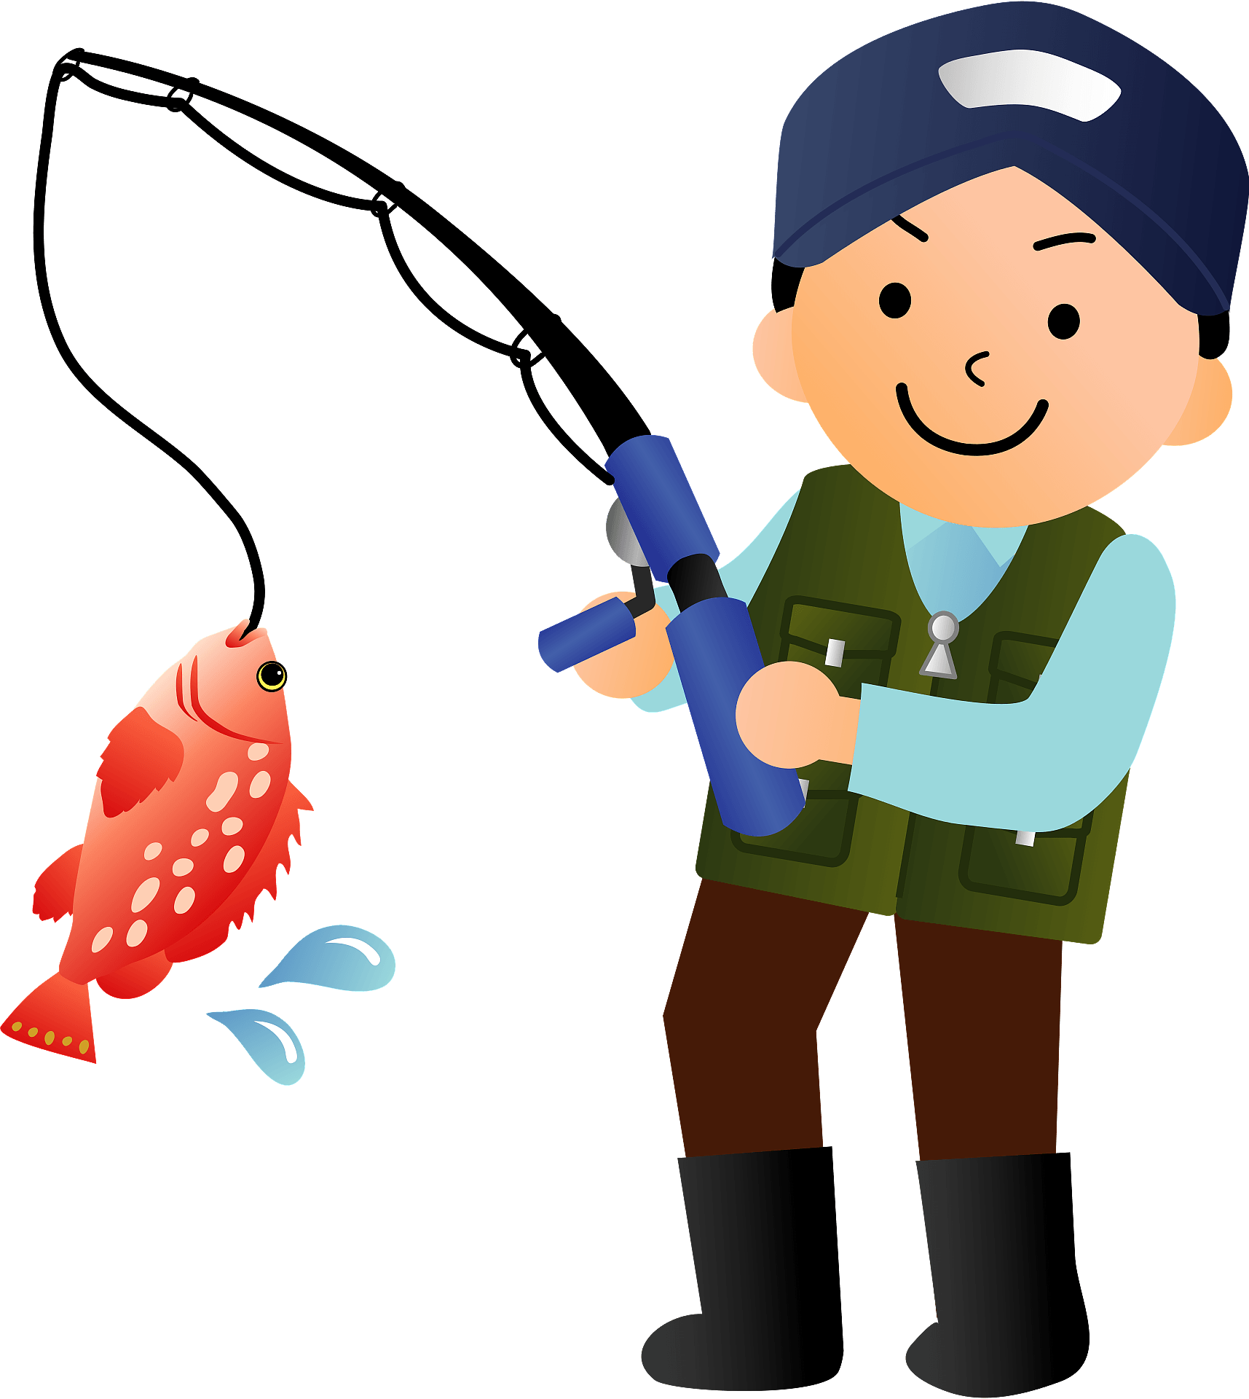
Find someone who can…
…teach me how to cook curry and rice.  Megumi  ____|____ | …teach me how to play baseball.  ____|____ | …teach me how to ride a unicycle.  ____|____ | …tell me when golden week starts.  ____|____ | …show me how to bake a cake.  ____|____
…tell me what Daraemon likes to eat.  ____|____ | …show me how to wrap a Christmas present.  ____|____ | show me how to play Splatoon  ____|____ | …teach me how to make omurice.  ____|____ | …tell me what is for lunch today.  ____|____
…tell me how to get to Miyajima.  ____|____ | …tell me when to watch Home Alone.  ____|____ | …tell me how old _______ is.  ____|____ | …teach me how to play the guitar.  ____|____ | …teach me how to speak English.  ____|____
…tell me where to buy ramen.  ____|____ | …teach me how to fold an origami crane.  ____|____ | …tell me what day Christmas is.  ____|____ | …tell me where to see the Northern Lights.  ____|____ | …tell me where to see the Nazca Lines.  ___|____
…teach me how to play the piano.  ____|____ | …tell me where to buy shoes.  ____|____ | …teach me how to swim.  ____|____ | …show me how to draw Doraemon.  ___|_____ | …tell me when to watch Anpanman  ____|____
Let`s make sentences!
Megumi
Example: ________ taught me how to make curry and rice.

- ____________________________________________________
- ____________________________________________________

- ____________________________________________________

- ____________________________________________________

- ____________________________________________________
GOOD JOB!

