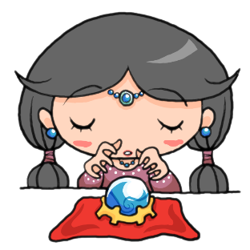
Do you have ESP?

 | circle |  | triangle |  | square

Partner 1: _______________________
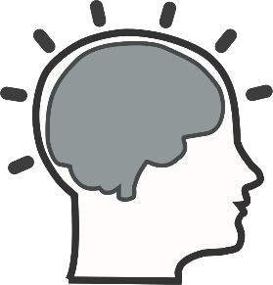
 | Shape
1 |  | Correct! | Sorry…
2 |  | Correct! | Sorry…
3 |  | Correct! | Sorry…
4 |  | Correct! | Sorry…
5 |  | Correct! | Sorry…
6 |  | Correct! | Sorry…
7 |  | Correct! | Sorry…

Total score: ____________________

Partner 2: _______________________

 | Shape
1 |  | Correct! | Sorry…
2 |  | Correct! | Sorry…
3 |  | Correct! | Sorry…
4 |  | Correct! | Sorry…
5 |  | Correct! | Sorry…
6 |  | Correct! | Sorry…
7 |  | Correct! | Sorry…
8 |  | Correct! | Sorry…

Total score: ____________________
