Task 1 part 1
Class( ) No.( ) Name( )

Learning SCIENCE in English
Food |  |  | 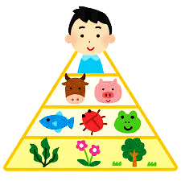
Main Ingredients
材料,具
Origins

Model Dialogue:
A: What is your favorite food? What is it made from?
B: My favorite food is curry and rice. It’s made from rice, vegetables, meat and spices.
A: What’s the origins of spices?
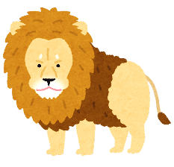
B: They’re originally from plants.
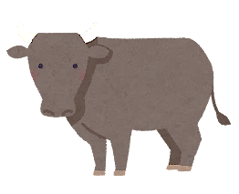
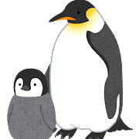

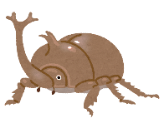
Task 1 part 2
Animal | Food and Its Origins
lions | deer grasses
Task 2 part 1
eagles (ワシ）
earthworms (ミミズ）
frogs (カエル）
snakes (ヘビ）
Write the answers for each circle

①
②
③
④

Task 2 part 2
Make sentences using the keywords below. Be careful about when to use passive voice and active voice!

Example:
Rabbits eat grasses.
Grasses are eaten by rabbits.

③ Frogs ④ earthworms.
③ Frogs ② snakes.
② Snakes ① eagles.
- Eagles rabbits.
Rabbits ① eagles.

