- I LIKE __.

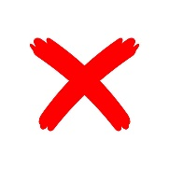 I DON’T LIKE __.

- I PLAY __.

I DON’T PLAY __.

