Name:____________________ No.:____ Class:___-___ Date:________

Train station information.
The pictures below show some causes of train delays. Please, think and write the causes in the boxes.

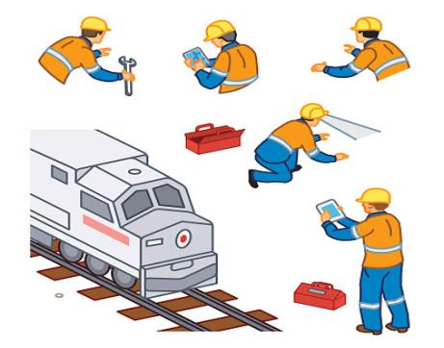
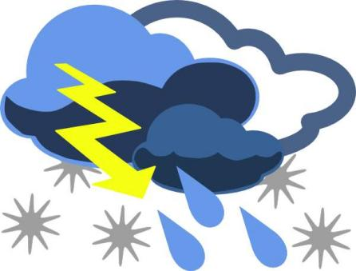

Example sentence;
The Sagami Line train has been delayed due to the storm.
Vocabulary words

Been delayed | 遅れた
Not running | 走っていない
Late | 遅い
Running on time | 時間通りに走る
15 | 15分
Running late | 遅れています
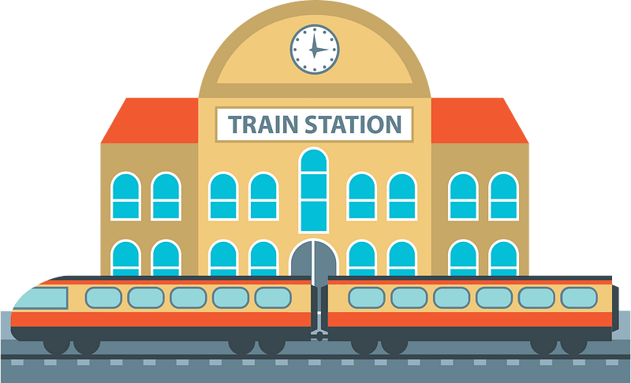

Try to complete these sentences using the examples in the table above.
- The Yokohama Line trains are __________ _________between Machida and Hashimoto.
- The Odakyu Line is ________ minutes ________ due to a passenger's illness.
- The Chuo Line train has _______ ____________.
- Some trains are ____________ while some others are _________ ________.

