Class: __年＿組 Number: __ Name: ___________________
Number: __ Name: ____________________
Present Continuous Form (現在進行形)
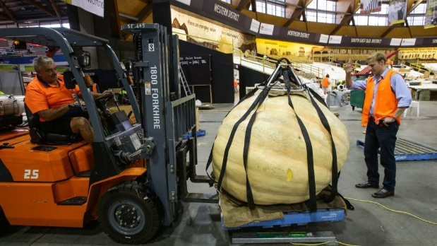
Let’s enjoy the Sydney Royal Easter Show! But, the giant pumpkin was stolen! Who stole the giant pumpkin? Listen to the clues and write ○ or ×.
728 kg

 | cafe | stadium | pavilion | stables | garden | paddock
Rod
John
Jacob
Keith
Mary
Bec

 | riding a horse | eating cake | riding a roller coaster | drinking wine | buying showbags | watching woodchopping
Rod
John
Jacob
Keith
Mary
Bec

Keith isn’t riding a roller coaster  Keith isn’t drinking wine  Mary isn’t watching woodchopping  Mary isn’t drinking wine  Mary isn’t in the cafe  Mary isn’t in the stadium  John isn’t in the garden  John isn’t buying showbags  Rod is in the stadium | Jacob is riding a horse in the paddock  Mary isn’t eating cake  Bec is buying showbags  The thief is in the cafe  Keith is in the garden  Bec is in the pavilion  The thief is drinking wine  Rod is eating cake
John is the pumpkin thief
Extra resources at:
www.eastershow.com.au

