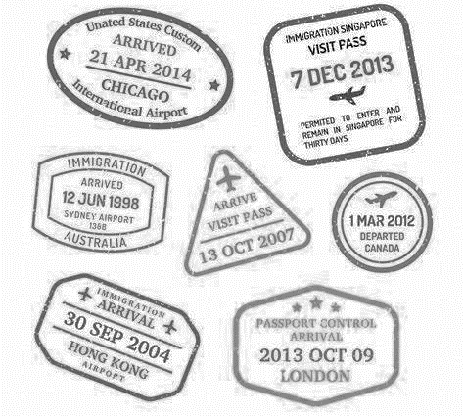
✏SIGNATURES✏

Name: ____________________________________ Date: ________________ Class: _______
Where are you going?  I’m going to ______. | Canada | South Korea | Italy | America
Where are you going to visit?  I’m going to visit ____. | Vancouver | Seoul | Rome | Hawaii
 | Toronto | Jeju Island | Venice | New York City
What are you going to eat?  I’m going to eat ____. | Maple Pancakes | Bibimbap | Pizza | Hamburger
 | Lobster | Barbecue | Gelato | Apple Pie
What are you going to see?  I’m going to see ____. | The Rocky Mountains | A k-pop concert | A gondola | A baseball game
 | An aurora | Seoul Tower | The Colosseum | The Grand Canyon

