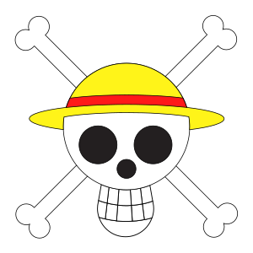

- She had written a novel on pirates. (write)
- He his homework yesterday. (do)
- They together on repairing the ship. (work)
- She a beautiful dress at the party. (wear)
- John to the wedding ceremony. (come)
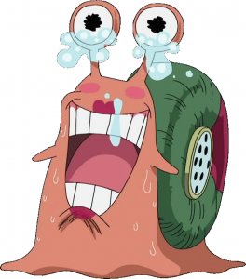
- the snake on his leg?(bite)
- He any cash amount to the pirate hunter. (not/pay)
- We any game from yesterday. (not/play)
- The car far away in the tornado. (blow)
- She her puppy on the road. (not/leave)

