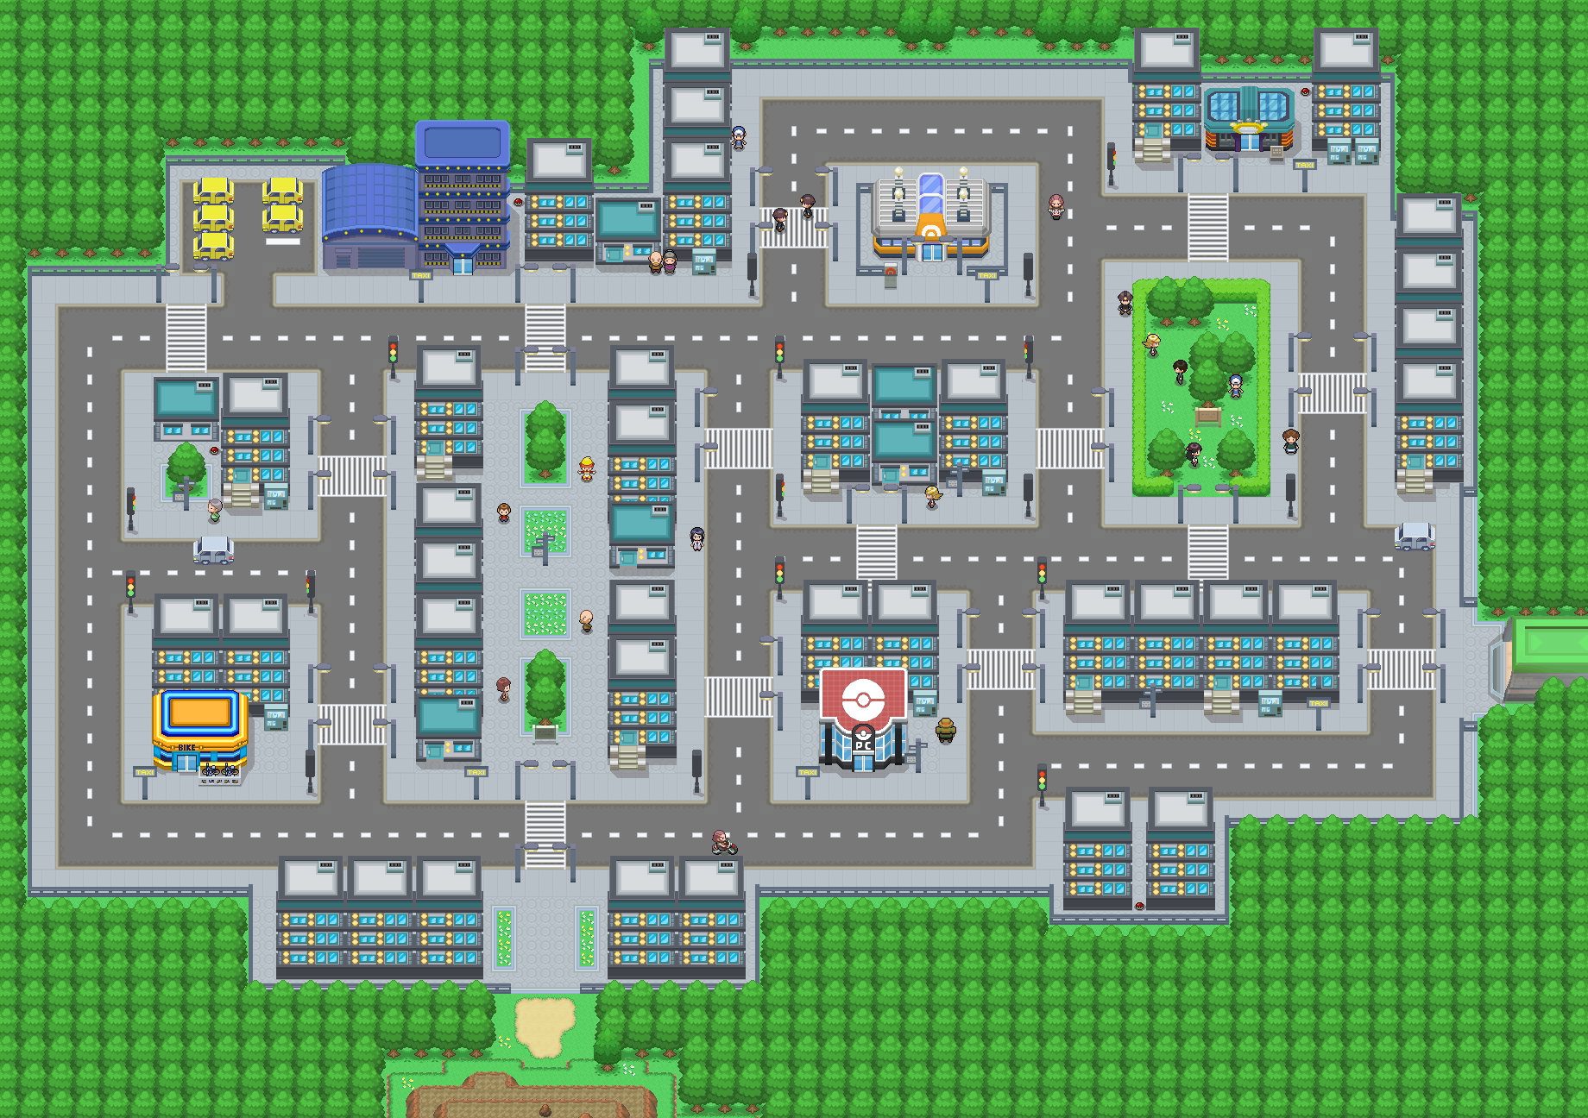

**City Hall**

**Tsushima Station**

**Bookstore**

**Supermarket**

**Home**

**Park**

**School**

**Hospital**

**Post Office**

**Library**

**Police Station**

**Department Store**



**City Hall**

**Tsushima Station**

**Bookstore**

**Home**

**Park**

**Library**

**Police Station**

**Department Store**



**A**

**Tsushima Station**

**Supermarket**

**Home**

**Park**

**School**

**Library**

**Police Station**

**Department Store**



**B**

**City Hall**

**Post Office**

**Bookstore**

**Home**

**Hospital**

**Police Station**

**Park**

**Tsushima Station**



**City Hall**

**Post Office**

**Bookstore**

**Department Store**

**Home**

**Hospital**

**Police Station**

**Library**

**Park**

**School**

**Supermarket**

**Tsushima Station**