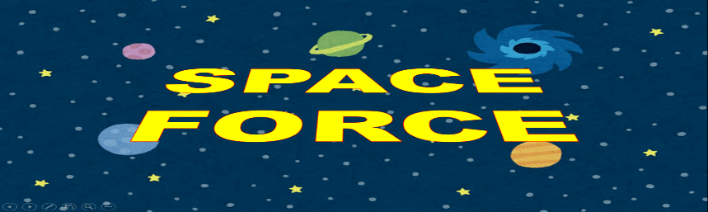
Name: ___________ Class: ____ Number: ____ Date: ____/_____
I’m sure  I’m afraid  I’m glad  I’m sad |  | I hope  I think  I believe  I wish
- ___________________________________________________________________
___________________________________________________________________
- ___________________________________________________________________
___________________________________________________________________
- ___________________________________________________________________
___________________________________________________________________
- ___________________________________________________________________
___________________________________________________________________
- ___________________________________________________________________
___________________________________________________________________
- ___________________________________________________________________
___________________________________________________________________
- ___________________________________________________________________
___________________________________________________________________
- ___________________________________________________________________
___________________________________________________________________
- ___________________________________________________________________
___________________________________________________________________
- ___________________________________________________________________
___________________________________________________________________
- ___________________________________________________________________
___________________________________________________________________
- ___________________________________________________________________
___________________________________________________________________
GROUP SHEET
We’re _______ that the movie was _______________.
We _______ that sushi is ___________________.
We’re _________ that it will be ___________ tomorrow.
We __________ that teacher isn’t _________ today.
We’re __________ that the party was _______________.
We ______ that recycling is ________________.
We’re _________ that Nobita can _________________.
We ___________ that our team is going to ________________.
We’re __________ that the tiger _____________________.
We _________ that we can _____________ this summer.
We’re ________ that our friend lost ______________.
We _________ that ________ is more important than _________.

