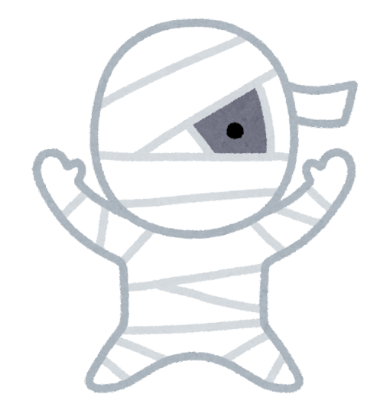

Popping Candy

Baby, if you want to Locate the Answer to this riddle,

just Contemplate the big things, not the small

things, oKay?

マシュマロ、グミ、チョコレート、いちご飴、ポッピングキャンディの5種類のキャンディです。また、キャンディの包み紙の色は、黒、青、オレンジ、緑、赤の5色です。謎を解いて、どのキャンディがどの包み紙に合うかを見つけてください。明かされない1色は、マシュマロキャンディと一致します。

Gummi Candy

First think of an insect that makes honey

Then think of the biggest size of French fries at McDonald’s

Next think of not I, not we, not them

Finally, think of a map, and look to the right

Chocolate

It’s the color of anger, the color you bleed

The color your eyes get if you don’t sleep

One Piece’s color (2022 movie one)

The color when your skin spends too long in the sun

Strawberry Candy

This color is shared by the flags of Ireland, Italy, Brazil, and Bangladesh.

What color is the

marshmallow candy wrapper?

There are five candy wrappers: blue, green, black, orange, and red.

Solve the riddles to learn what color matches what candy!