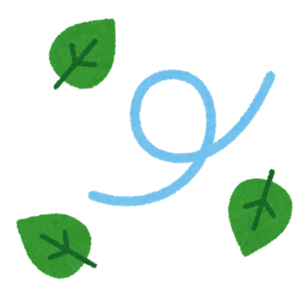Fallen Leaves | Fallen Leaves | Fallen Leaves
Fallen Leaves | Fallen Leaves | Fallen Leaves
Fallen Leaves | Fallen Leaves | Fallen Leaves
Fallen Leaves | Fallen Leaves | Fallen Leaves
Earthworms | Earthworms | Earthworms
Earthworms | Earthworms | Earthworms
Earthworms | Earthworms | Earthworms
Earthworms | Earthworms | Earthworms

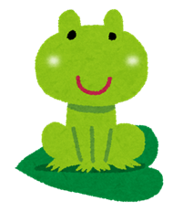  Frogs | Frogs | Frogs
Frogs | Frogs | Frogs
Frogs | Frogs | Frogs
Frogs | Frogs | Frogs
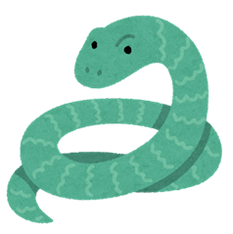  Snakes | Snakes | Snakes
Snakes | Snakes | Snakes
Snakes | Snakes | Snakes
Snakes | Snakes | Snakes

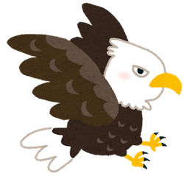  Eagles | Eagles | Eagles
Eagles | Eagles | Eagles
Eagles | Eagles | Eagles
God | God | God

