What time did the crime happen?

Solve this candy math quiz to find out!

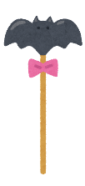



算数で、それぞれの棒状キャンディが表す数を求めます!

What was left behind at the crime scene?

Crack the secret code to get this clue!

+ 8 = 14 = -

- = 6 = ( - ) ÷

X = 20 = -

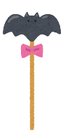

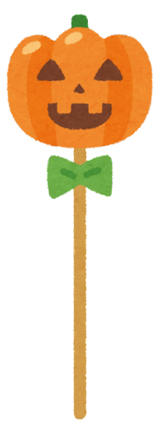 X =

Time of the Crime

: a.m.