**Let’s Talk 2**

Name ___________________________________ Class _____ Number _____

|  |  |
| --- | --- |
| **English** | **Japanese** |
| ②  A: Excuse me. Do you need some help?  B: ( ____________ ) ( ____________ ). Could you help me buy a ticket?  A: ( ________ ) ( ______________ ).  Where would you like to go?  B: I’d like to go to Wakaba Station. | A:すいません。お手伝いが必要ですか？  B:はい、お願いします。  切符を買うのを手伝ってくれませんか。  A:もちろん。どこへ行きたいですか？  B:若葉駅に行きたいのですが。 |
| ③  A: Hi. What’s ( ___________ )? Are you lost?  B: **Y**es.  A: Where are your mom and dad?  B: I ( ___________ ) ( ___________ ).  A: OK. I’ll take you to the   ( ___________ ) ( ___________ ).  B: **Y**es. | A:こんにちは。どうしたの？道に迷ったの？ B:うん。  A:あなたのお母さんとお父さんはどこですか。 B:わからない。 A:わかった。交番まで連れて行ってあげる。 B:うん。 |

**Step 1**

Let’s practice new English!

A: Excuse me. **Can I help you?**

B: Oh, yes please. Do you know where Midori City Hotel is?

A: Midori City Hotel? **Y**es. **Shall I** take you there?

B: Thank you. That’s very kind of you.

A: **Would you like me to** carry your umbrella or something?

B: Oh. Thank you very much.

**New Words**

- *That’s very kind of you.*

- *would like … to~*

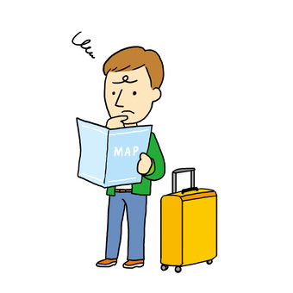

Write the English words.

**Step 2**

|  |  |
| --- | --- |
| **English** | **Japanese** |
| ①  A: ( _____________ ) ( __________ ). Can I help you?  B: Oh, yes please. Could you tell me where I can get a taxi?  A: ( ____________ ). Shall I take you there?  B: Oh, ( ___________ ) ( ________ ). | A:すいません。  お手伝いしましょうか？  B:あぁ、はい、お願いします。どこでタクシーを拾えるか教えてくれませんか？  A:もちろん。そこまでお連れしましょうか？  B:あぁ、ありがとうございます。 |

A: __________________________________________________________________________

B: __________________________________________________________________________

A: __________________________________________________________________________

B: __________________________________________________________________________

A: __________________________________________________________________________

B: __________________________________________________________________________

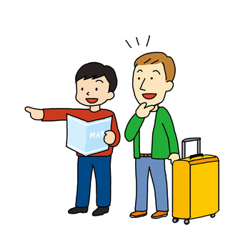

**<Tool Box>**

Do you need some help? No, thank you. I’m fine.

お手伝いが必要ですか。 いいえ。だいじょうです。

Is there anything I can do for you? **Y**ou’re a lifesaver.

何かできることがありますか。 本当に助かります。

Sorry, I can’t help you. I’m in a hurry.  
お役に立てずごめんなさい。急いでいるのです。

**Step 3**

Check your paper. Make a conversation with your group.