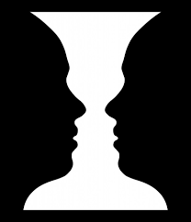
Optical Illusions
Example- Is it a vase or two people?
I think that it is a vase.

- Is the cat going up or down the stairs? (it is going)
______________________________________________________________________
- What animal is it? (it is a)
______________________________________________________________________
- Is it a rabbit or a raven? (it is a)
______________________________________________________________________
- Is the woman young or old? (she is)
______________________________________________________________________
- Is it two or three people? (it is)
______________________________________________________________________
- What animal is it? (it is a)
______________________________________________________________________
- Is it a man running or a dog? (it is a)
______________________________________________________________________
- What animal is it? (it is a)
______________________________________________________________________
- How many legs does the elephant have? (it has)
______________________________________________________________________
- Is it a man or a dog? (it is)
______________________________________________________________________
- Is the bus going left or right? (it is going)
______________________________________________________________________
- Is it a face or someone walking? (it is)
______________________________________________________________________
- Do the lines have the same or different length? (they have)
______________________________________________________________________
- Is the ballerina turning right or left? (she is)
______________________________________________________________________
- Is the image disappearing? (it is / it is not)
______________________________________________________________________
- Are the dots disappearing? (they are / they are not)
______________________________________________________________________
- What color is the dress? (it is)
______________________________________________________________________

Useful phrases:
- In my opinion, ~
- I think that ~ / I don’t think that ~
- I agree with you. ~ / I don’t agree with your opinion. ~
- I see it too. / I don’t see it.
- That’s a good point. ~ / I understand your point. However, ~
- I’m not sure about that. ~
- Wow! That’s crazy!

