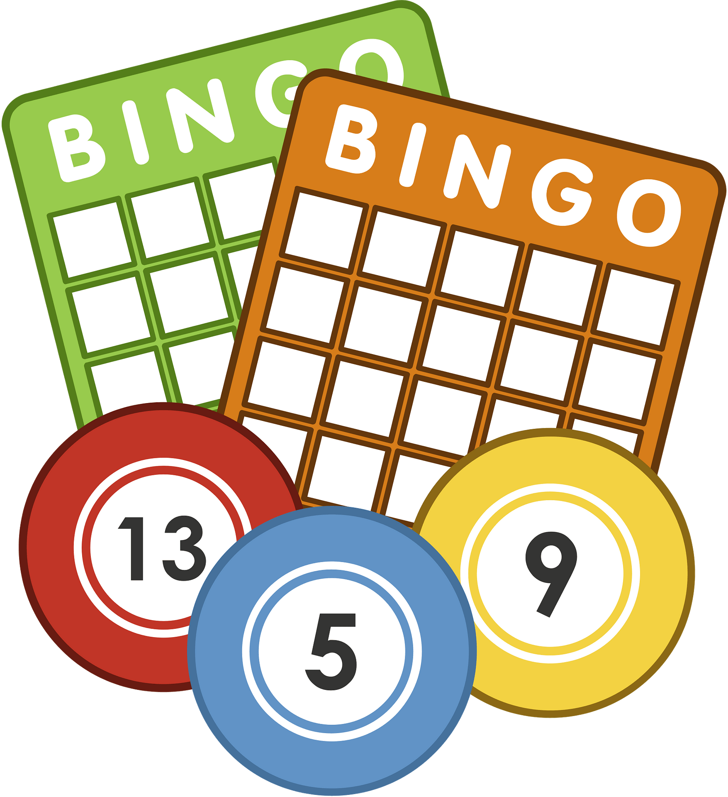
Name:____________________ Class:_______HR

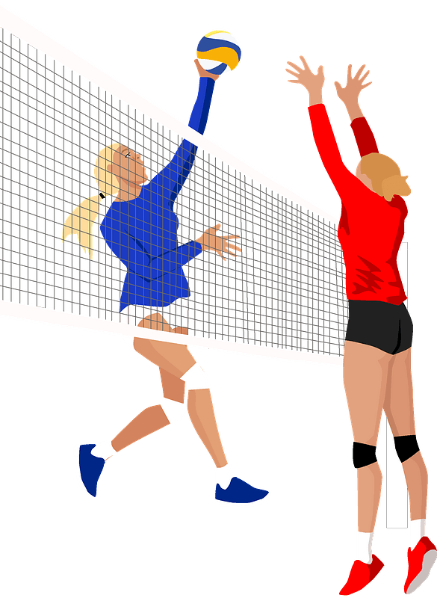
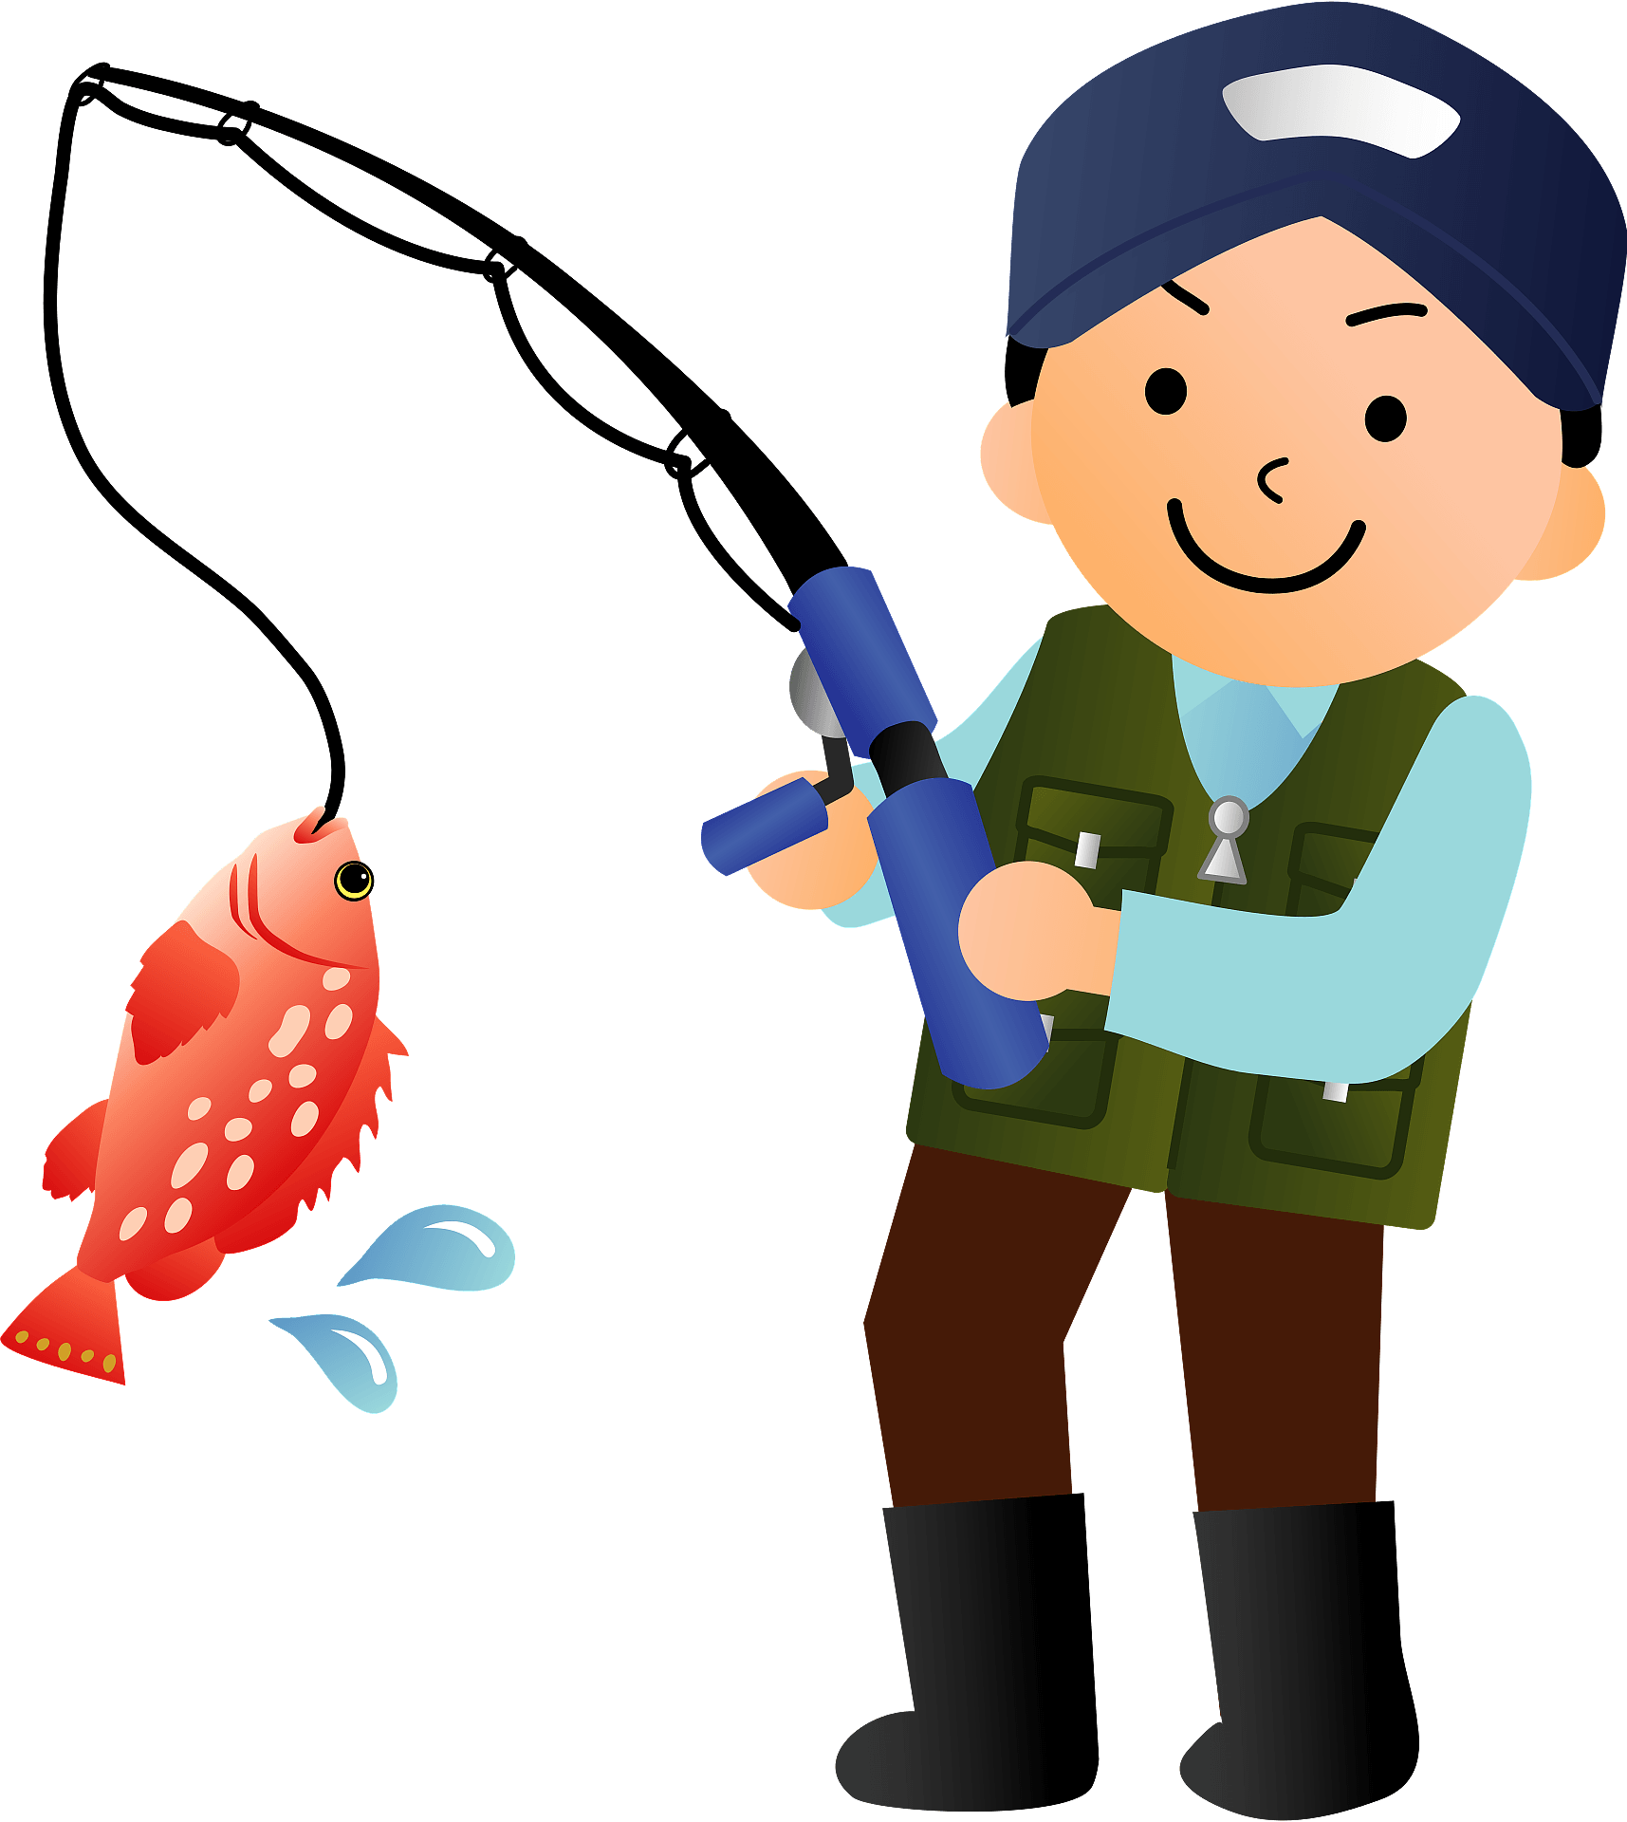
Find someone who knows…
…how to cook curry and rice.  ________ | …how to play baseball.  ________ | …how to ride a unicycle.  ________ | …when golden week starts.  ________ | …how to bake a cake.  ________
…________s favorite color.  ________ | …how to wrap a Christmas present.  ________ | …how to play baseball.  ________ | …how to make omurice.  ________ | …how to fish.  ________
…how to get to Mt. Fuji.  ________ | …three cities in Australia.  ________ | …how old ________ is.  ________ | …how to play the guitar.  ________ | …how to speak English.  ________
…how to garden.  ________ | …how to fold an origami crane.  ________ | …what day Christmas is.  ________ | …3 prefectures in Chubu.  ________ | …how to play volleyball.  ________
…how to play the piano.  ________ | …how to say hello in 3 languages.  ________ | …how to swim.  ________ | …how to draw Doraemon.  ________ | …how to tie a necktie.  ________

Let`s make sentences!
name
Example: ________ knows how to make curry and rice.
- ____________________________________________________

- ____________________________________________________

- ____________________________________________________

- ____________________________________________________

- ____________________________________________________
GOOD JOB!

