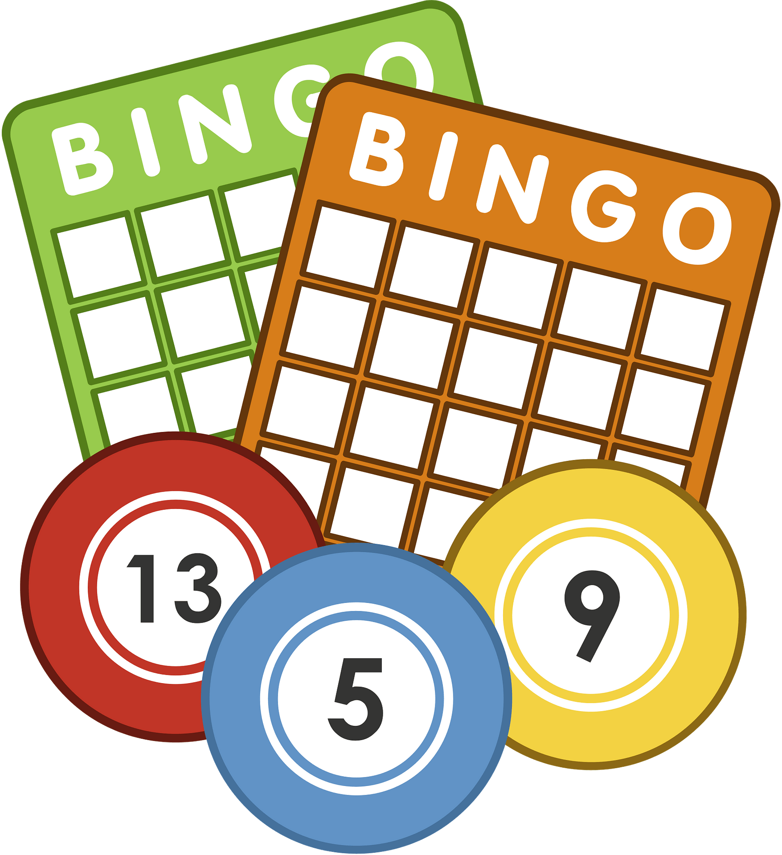
NAME:__________________ HR:_________
Example
Q. Did you go to school today?
A. Yes, I did.
Q. Did you _________?
A. Yes, I did. / No, I didn’t.

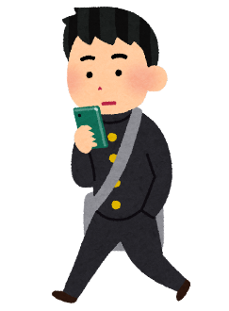
Ask your classmates and try to score a BINGO!
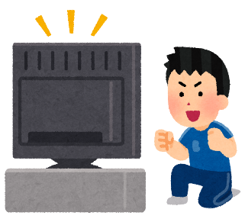
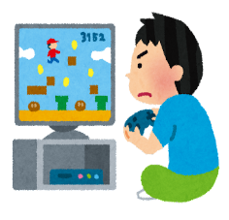
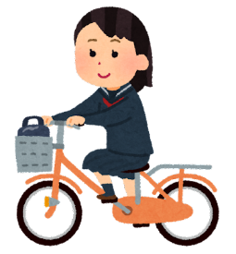
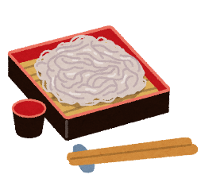
Did you…
walk to school today?  ________ | visit a shrine on New Years?  ________ | play sport yesterday?  ________ | drive to school today?  ________ | eat soba on New Years?  ________
play baseball on the weekend?  ________ | watch YouTube yesterday?  ________ | see fireworks on New Years?  ________ | shower this morning?  ________ | watch anime yesterday?  ________
play computer games yesterday?  ________ | ride your bike to school today?  ________ | say ‘hello’ to _____ today?  ________ | listen to music yesterday?  ________ | study yesterday?  ________
brush your teeth today?  ________ | practice an instrument on the weekend ?  ________ | watch a movie on the weekend?  ________ | eat fish last night?  ________ | play soccer on the weekend?  ________
try omikuji on New Years?  ________ | eat breakfast today?  ________ | go shopping on the weekend?  ________ | play tennis on the weekend?  ________ | watch TV  yesterday?  ________

