T-shirt activity
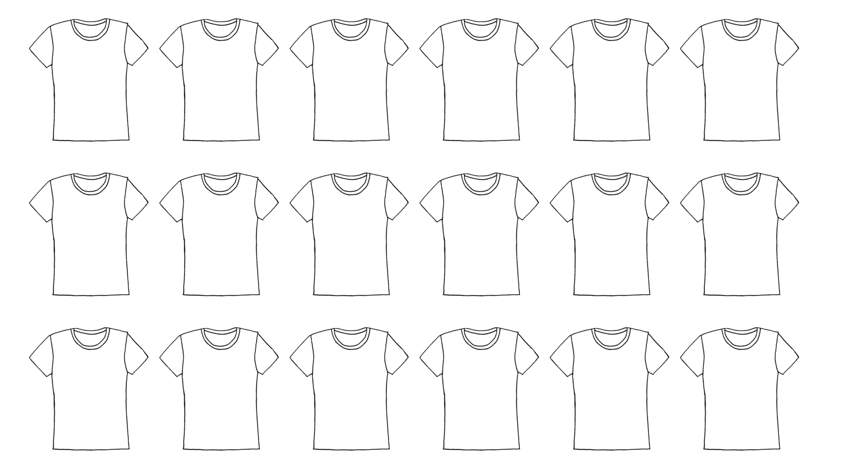
Name:_______________________________________ Grade______Class______.

