Pictures of Our Beautiful Planet

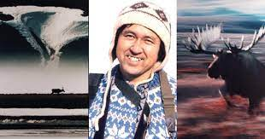
Name:________________________

1. What changed Hoshino Michio’s life?
a) a letter from the mayor of Shishmaref b) a trip to Shishmaref village
c) a photograph of a small village in Alaska d) a photograph of the mayor of Shishmaref

2. One day, Michio was very attracted to
a) a photograph of Alaska b) a photograph in a book about Alaska
c) a book about the Inuit d) a photograph of the Inuit people

3. How do you spell 写真 in English? _______________________________

4. Michio dreamed of visiting a small village called Shishmaref. True False

5. How did Michio get an invitation to Shishmaref village?

_________________________________________________________________________________

6. What does wilderness mean?
a) This place has no people, buildings or roads. It only has wild animals.
b) This place has Sugi-chan’s house.
c) This place has many Alaskan villages.
d) This place has only one village.

7) Michio sent the letter to the mayor by email. True False

8) How long did it take for Michio to get a reply to his letter?
a) one day
b) one week
c) one month
d) 6 months

