Wish Interview Bingo
A: Who do you wish you could meet?
B: I wish I could meet Otani Shohei.
Write your answers.
Interview.
Who do you wish you could meet?  I wish I could meet... |  | 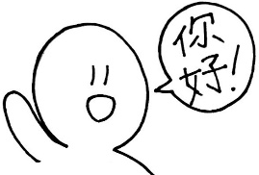  What language do you wish you could speak?  I wish I could speak... | 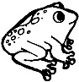  What animal do you wish you could be?  I wish I could be a(n)...
自分の答え
相手の名前 |  |  | 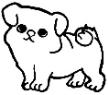
相手の答え
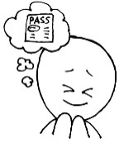  What thing do you wish you had?  I wish I had a(n)... |  | Where do you wish you could live?  I wish I could live in... | What do you wish you could do after this class?  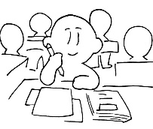  I wish I could...
自分の答え
相手の名前
相手の答え
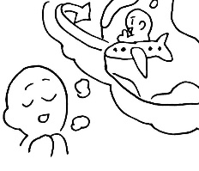  Where do you wish you could go on a trip?  I wish I could go on a trip to... |  | How old do you wish you could be?  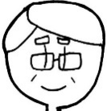  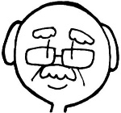  I wish I could be... | Do you wish you could fly like a bird or swim like a fish?  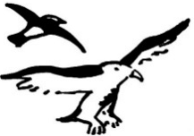  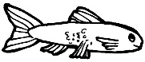  I wish I could...
自分の答え
相手の名前
相手の答え

