Name: ______________ Class: ____ Number: ___ Date: ___/____
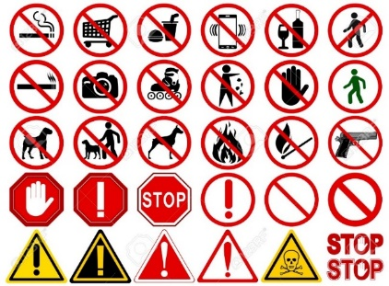
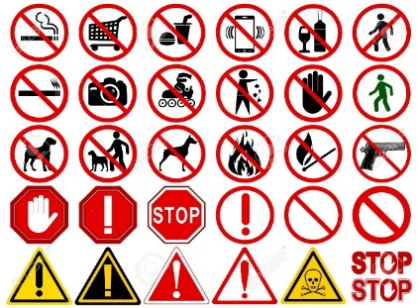
You must...
You must not...
SIGNS
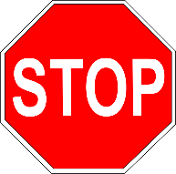
POINT GAME
例：You must ＿＿＿.
- ________________________________________

- ________________________________________

- ________________________________________

- ________________________________________

- ________________________________________

- ________________________________________

- ________________________________________

- ________________________________________
Yes, Sir!
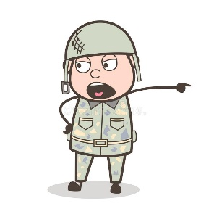
You’re the BOSS!

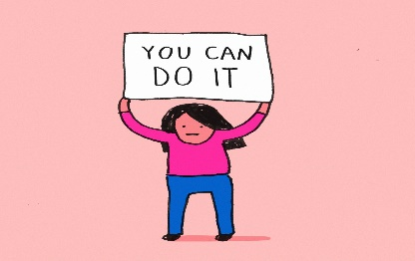
MAKE YOUR OWN SIGNS

- _____________________________

- _____________________________

- _____________________________

- _____________________________

- _____________________________

- _____________________________

- _____________________________

- _____________________________

