Name: ____________________ Class: ___ Number: ___
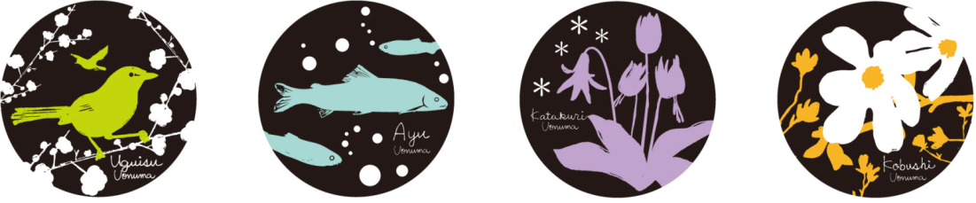

例 ‘Where is food bought here?’
Food is bought at the farmers market.
We have many fresh vegetables and good rice.
- ____________________________________________________
____________________________________________________
- ____________________________________________________
____________________________________________________
- ____________________________________________________
____________________________________________________
- ____________________________________________________
____________________________________________________
- ____________________________________________________
____________________________________________________
- ____________________________________________________
____________________________________________________
- ____________________________________________________
____________________________________________________
8. ____________________________________________________
______________________________________________________
- What sports are enjoyed in Uonuma?
- What food is made here?
- Where are fish caught here?
- When are wild animals seen here?
- What season is enjoyed the most here?
- What is event is held here?
- What place is visited the most here?
- Who is seen on TV from here?

- What sports are enjoyed in Uonuma?
- What food is made here?
- Where are fish caught here?
- When are wild animals seen here?
- What season is enjoyed the most here?
- What is event is held here?
- What place is visited the most here?
- Who is seen on TV from here?

