Oh no! Olaf seem to have misplaced his carrot nose. Help him find where to put his nosey nose.

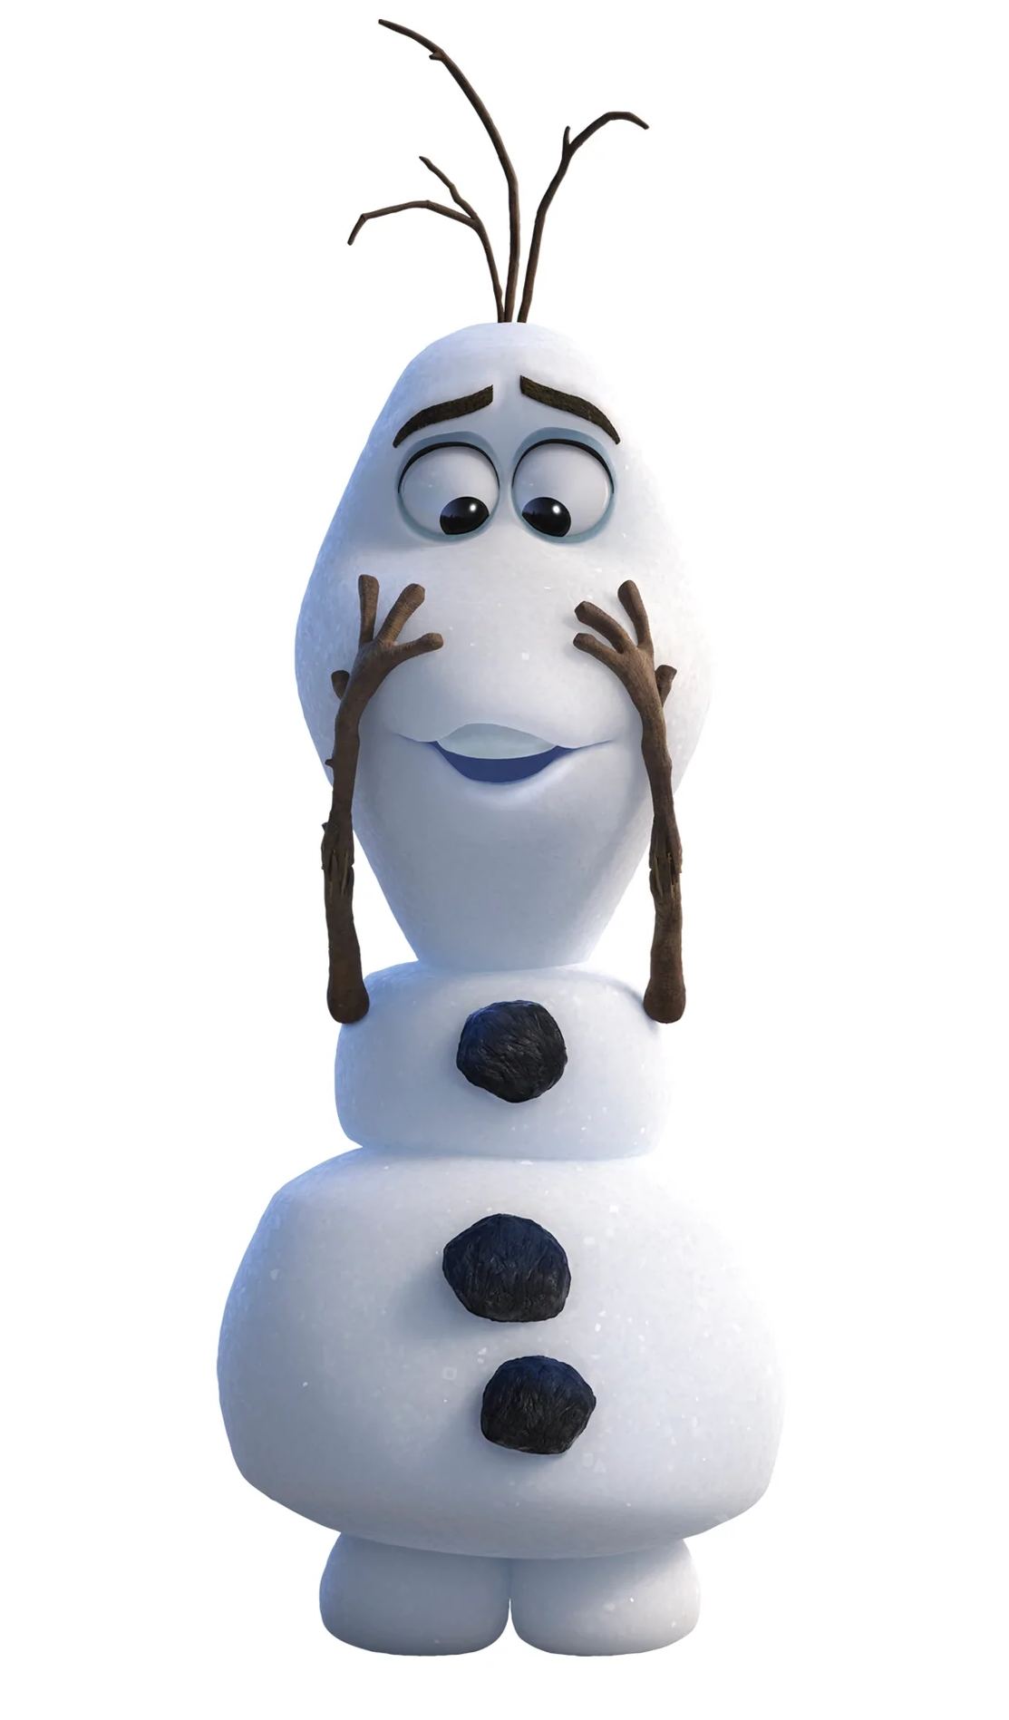

**Pin the nose on Olaf**

