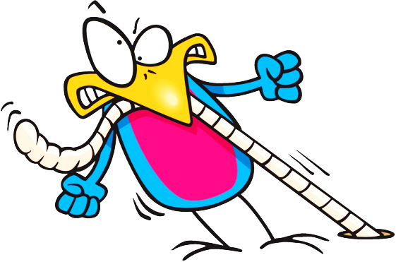

Name: _________________

The early bird…

…gets the worm.

#1

What time do you __________________?

I ___________________________.

Name: ____________

Time: ____:____ ____

Name: ____________

Time: ____:____ ____

Name: ____________

Time: ____:____ ____

____________　is the early bird.

#2

I ___________________________.

What time do you __________________?

Name: ____________

Time: ____:____ ____

Name: ____________

Time: ____:____ ____

Name: ____________

Time: ____:____ ____

_____________________ is the early bird.

I ___________________________.

What time do you __________________?

#3

Name: ____________

Time: ____:____ ____

Name: ____________

Time: ____:____ ____

Name: ____________

Time: ____:____ ____

_______________________ is the late bird.

I ___________________________.

What time do you __________________?

#4

Name: ____________

Time: ____:____ ____

Name: ____________

Time: ____:____ ____

_______________________________ late.

Name: ____________

Time: ____:____ ____

Name: ____________

Time: ____:____ ____

Name: ____________

Time: ____:____ ____

Name: ____________

Time: ____:____ ____

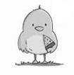

I’m happy. I’m the late bird.

I don’t like worms.

____________________ is the late bird.

I’m happy. I’m the late bird.

I don’t like worms.

What time do you ___________?

I’m happy. I’m the late bird.

I don’t like worms.

I _____________________.

#6

Name: ____________

Time: ____:____ ____

_______________________________ late.

Name: ____________

Time: ____:____ ____

Name: ____________

Time: ____:____ ____