Where do you want to go?
Step 1: Where do you want to go in Japan? What do you want to do there? ★ORIGINAL OK★
---WRITE SOME SENTENCES---
I
D
E
A
s
Okinawa  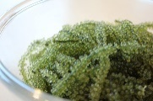  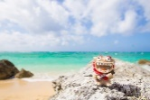  the beach / sea grapes | Osaka  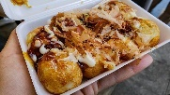  takoyaki / Dotonbori | Kagoshima  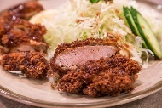  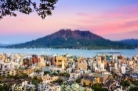  Sakurajima / black pork | Mie  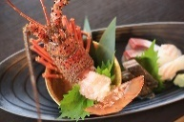  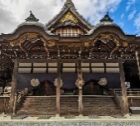  Ise Jingu / Ise ebi
Kyoto  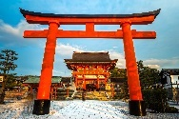  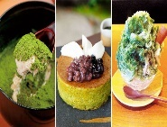  matcha / the temples and shrines | Chiba  Tokyo Disneyland | Hokkaido  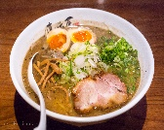  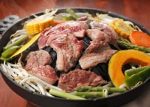  Jingisukan / ramen | Fukuoka  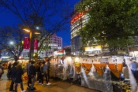  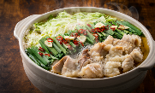  yatai / motsunabe
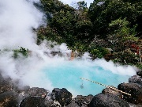  Oita  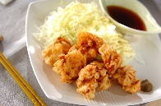  the hot springs / toriten | Nara  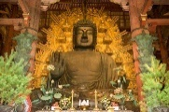  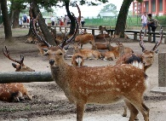  the deer / the temples | Kanagawa  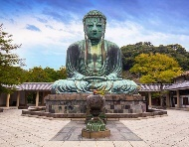  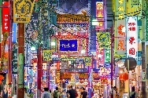  Chinatown / Kamakura | Hyogo  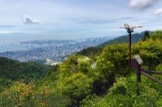  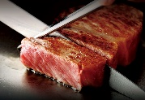  Kobe Beef / Mount Rokko

動詞原形
to visit | to relax (in/at) | to meet | to go to | to climb | to eat
to enjoy  楽しむ | to walk around in  歩き回る |  | to experience 経験する | to taste  味わう | to have fun in/at/on  楽しむ

例: I want to go to Okinawa to eat sea grapes. / I want to go to Okinawa to relax at the beach.
- I want to go to + 都道府県 + to 不定詞 + 目的語.
- ____________________________________________________________________.
- ____________________________________________________________________.
- ____________________________________________________________________.
- ____________________________________________________________________.
- ____________________________________________________________________.

Step 2: Ask your partner!
Questions: ① Where do you want to visit? I want to go to 都道府県.
② Why do you want to go there? I want to go there + to不定詞 + 目的語.
Prefecture | Why do they want to go there?
例） Okinawa | to visit the beach
Name ( ) Class ( ) No ( )

